JOB DESCRIPTION

Job Title: | Pacific Islander Junior Professional - PCREEE
Division/Programme  and Section/Project (if any): | Georesources and Energy Programme – Geoscience, Energy and Maritime Division
Location: | Nuku’alofa, Tonga
Reporting to: | Programme Delivery Officer / Manager PCREEE
Number of Direct Reports: | No Direct report
Purpose of Role: | To support the Manager – PCREEE including Programme Delivery Officer and PCREEE Experts with providing support and advice to governments, stakeholders and the private sector in planning and implementing PCREEE activities, focusing on entrepreneurship, investment promotion and capacity development relating to renewable energy and energy efficiency.
Date: | November 2018

Organizational Context and Organization Chart

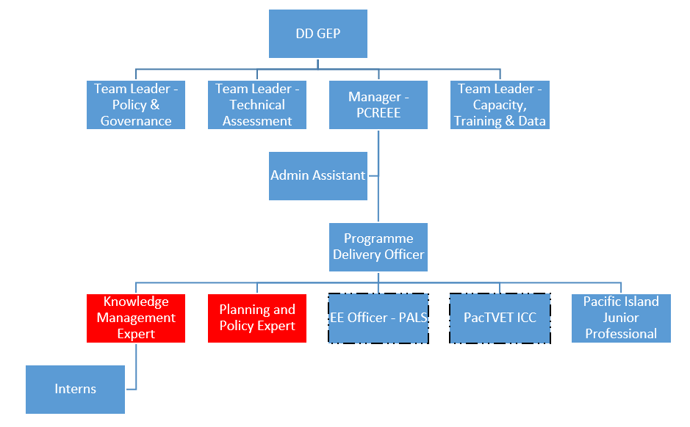

Key Result Areas (KRAs):

The position of Pacific Islander Junior Professional (PCREEE) encompasses the following major functions or Key Result Areas:

Regional Collaboration, Coordination and Communication – Assist in fostering partnerships and collaborations with national and regional partners.

Technical Cooperation and Services – Assist in the implementation of the annual work plan of the PCREEE.

Resource mobilisation – Contribute to the resource mobilization effort of the PCREEE

The performance requirements of the Key Result Areas are broadly described below

Jobholder is accountable for | Jobholder is successful when
Regional Collaboration, Coordination and Communication  - Assists with conducting and updating of needs assessments  - Assist with the data collection and analysis effort of the PCREEE  - Assist with the visibility effort of the PCREEE  - Assist with the updating of the PCREEE website. | - There is a comprehensive and up-to-date mapping of effort, projects and technical assistance in PICTs allowing PCREEE to identify gaps and niches where it can best intervene  - Data and information are collected to assess impacts and recent status of RE and EE in the PICTs  - News items and public releases on RE and EE in the PICTs are quickly captured and reflected in the PCREEE website  - The PCREEE website continuously contributes to promoting the Global Network of Sustainable Energy Centres (GN-SEC) and becomes the “go-to” website on RE and EE in the PICTs.
Technical Cooperation and Services  - Assist in the implementation of the PCREEE entrepreneurship activities  - Assist in the planning an conduct of business and investment promotion activities  - Assist in the planning and conduct of PCREEE training activities | - Activity reports are produced in a timely manner  - Investment forum activities are professionally conducted and their impacts are accurately assessed and documented  - All PCREEE training activities are conducted according to plans and comprehensively reported, including their gender dimensions.
Resource mobilisation  - Draft funding proposals to internal resources in SPC as well as to external sources  - Draft bids and proposals to consultancy works in member countries and those offered by regional and multilateral stakeholders  - Assist in the production of progress and acquittal reports on resources provided to the PCREEE | - PCREEE funding proposals are submitted on time and get funded  - PCREEE consultancy proposals are submitted on time, are competitive and are offered the consultancy.  - Progress and financial reports are prepared and submitted in a timely manner.

The above performance requirements are provided as a guide only. The precise performance measures for this job will need further discussion between the jobholder and supervisor as part of the performance development process.

Most Challenging Duties Typically Undertaken (Complexity):

- Conducting in-country activities at remote locations.
- Collecting data from sources who are reluctant to release them
- Conducting joint activities and synchronizing the various needs and agendas of partners
- Dealing with the private sector and business people who may not have time to fully participate in PCREEE events

Functional Relationships & Relationship Skills:

Key internal and/or external contacts | Nature of the contact most typical
External:  - CROP agencies, government technical staff, NGOs, stakeholders, private sector  - Technical partners  Consultants | - Negotiating, gaining cooperation, reporting  - Liaising, gaining cooperation, reporting  - Collaborating, assisting, advising
Internal  - GEM, Deputy Director and other staff in GEP including PAs  - Staff from other sections, Finance, Human Resources, Publications, Registry etc. | - Explaining, gaining cooperation, resolving minor conflicts, reporting  - Liaising, collaborating, resolving minor conflicts

Level of Delegation:

The position holder:
- is a programme officer in the PCREEE structure,
- liaises and works closely with other component areas under the GEP programme
- communicates with some national and technical contacts at the country level
- communicates and collaborates with private sector counterparts
- undertakes and supports in-country training and capacity building as well as data entry.

Personal Specification:

This section is designed to capture the expertise required for the role at the 100% fully effective level. (This does not necessarily reflect what the current position holder has.) This may be a combination of knowledge / experience, qualifications or equivalent level of learning through experience or key skills, attributes or job specific competencies.

Qualifications

Essential: | Desirable:
- University degree or equivalent in a discipline relevant to renewable energy and energy efficiency, or related field.  - Completed short term training relating to energy | - Qualification in another relevant field (e.g. economics, engineering).

Knowledge/Experience

Essential: | Desirable
- At least three years’ direct relevant experience in Pacific Islands energy sector  - Currently employed in the energy sector of the PICTs – public or private  - Understanding of current Pacific Island regional energy scene, and experience of working with gender issues relating to energy  - Excellent communication skills (oral and written) in English  - Excellent interpersonal skills, ability to work in a team as well as undertake unsupervised work, and communicate with people from different ethnic, cultural and educational backgrounds  - Strong PC based computer skills (Microsoft Word, Excel, PowerPoint and Outlook) with knowledge of software programmes for data entry and analysis  - Willingness to travel and undertake overseas assignments in SPC member countries, sometimes under difficult physical conditions. | - A prior experience or involvement with the business community and the private sector  - Experience in developing and implementing energy sector plans  - Working knowledge of French

Key Skills/Attributes/Job Specific Competencies

The following levels would typically be expected for the 100% fully effective level:
Expert level | - Effective Project Development and Management
Advanced level | - Awareness Raising and Resource Mobilization
Working knowledge | - Crosscutting issues such as climate change and vulnerability  - Data analysis and interpretation of results  - Energy Audit and Appliance Labelling and Standards  - Renewable energy design and maintenance
Awareness | - Broader energy security and development issues  - Relevant social and economic issues in the Pacific  - Gender issues and human rights-based approached to sustainable energy, with ideas about how to increase the participation of women and youth in delivering PCREEE programme outcomes.

Key Behaviours

All employees are measured against the following Key Behaviours as part of Performance Development:
- Demonstrating Personal Accountability
- Applying Expertise
- Working Together
- Creating Value for Customers
- Communicating Effectively
- Building Individual Capacity

Personal Attributes

- Physically fit
- Ability to work in a group
- Clear and effective communicator
- Ability to think on and off your feet
- Ability to sum up the situation and make decisions quickly if required, especially in the field.

Change to Job Description:

From time to time it may be necessary to consider changes in the job description in response to the changing nature of the work environment - including technological requirements or statutory changes. Such change may be initiated as necessary by SPC. This Job Description may also be reviewed as part of the preparation for performance planning for the annual performance cycle.

Approved:

Manager/Supervisor Date

Employee Date

