POSITION DESCRIPTION

Job Title: | Programme Assistant
Work Unit: | Pacific Centre for Renewable Energy and Energy Efficiency (PCREEE)
Location | Nuku’alofa, Tonga
Responsible To: | Manager – PCREEE
Number of direct reports or total head count: | 0
Job Purpose: | The Programme Assistant will provide support to the PCREEE to strengthen its administration, finance reporting and communication and awareness capacity to cope with the increasing number of staff and activities of the PCREEE.
Date: | April 2022

BACKGROUND

GEOSCIENCES, MARITME AND ENERGY DIVISION
The Geoscience, Energy and Maritime (GEM) Division has been established, a product of the merge between the Geoscience Division and the Economic Development Division. The GEM Division encompasses the following areas of Scientific Excellence: Georesources and Energy, and Disaster and Community Resilience, and Oceans and Maritime.

THE PACIFIC CENTRE FOR RENEWABLE ENERGY AND ENERGY EFFICIENCY (PCREEE)

The Pacific Centre for Renewable Energy and Energy Efficiency (PCREEE) was established in April 2017 and is part of a wider international multi-stakeholder partnership, which aims at the creation of a global network of regional sustainable energy centres for SIDS in the Pacific, Caribbean, Indian Ocean and Africa and other regions of the world too. The Centre is established with technical support of the United Nations Industrial Development Organization and financial support of the Governments of Austria and Norway. The Centre is a member of the Global Network of Regional Sustainable Energy Centres (GN-SEC) and works closely with 9 other regional centres in the global network.

The PCREEE will address gaps in the current effort to remove existing barriers and strengthen drivers for sustainable energy markets, industries and innovation through regional methodologies and tools. It marked the completion of its First Operational Phase 2017 – 2021 with the launch of its Business Plan 2021 – 2030 and its four Programme Areas:

- Sustainable Energy Business Start-up, mentoring and entrepreneurship
- Renewable Energy and Energy Efficiency for sustainable mobility
- Renewable Energy mini-grids
- Investments in Energy Efficiency

Organisation Context:

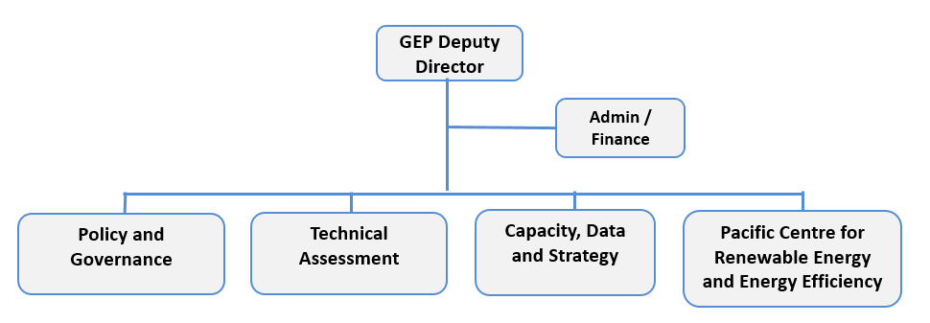
Capacity, Training and Data
Team Leader
Pacific Centre for Renewable Energy and Energy Efficiency
Manager
Admin / Finance
2
3
4

Key Result Areas:

The position of Programme Assistant encompasses the following major functions or Key Result Areas:

- Office Management – 40%
- Data Entry – 20%
- Monitoring and Evaluation – 20%
- Communication – 20%

Jobholder is accountable for | Jobholder is successful when
KRA 1: Office Management  - Put in place a safe and accurate record keeping system for the PCREEE, including keeping a registry of all assets purchased and kept by the Centre  - Organize meetings, trainings and including the PCREEE Steering Committee meetings and ensure logistics are in place for these events  - Prepare travels of the PCREEE team and those of others sponsored and covered by the SPC and PCREEE  - Prepare purchase orders, invoices, payment vouchers and perform the bank reconciliation and financial reporting of the PCREEE  - Keep an updated payments tracking framework for the PCREEE  - Responsible for the overall cleanliness and tidiness of the PCREEE | - Accurate and timely submission of monthly updates on PCREEE accounts, staff and assets to SPC in Suva  - Meetings, trainings and the PCREEE Steering Committee meetings are effectively organised according to plans  - Travels logistics are organized on time and travellers fully comply with SPC’s travel policy  - Financial transactions of the PCREEE are compliant with SPC’s and / or donors’ procurement policies  - There is minimal complaints from vendors on the timeliness of their payments  - PCREEE office is always clean and tidy
KRA 2: Data Entry  - Conduct the entry of PCREEE-specific data and info into the Pacific Regional Data Repository, PCREEE’s knowledge hub and other specific PCREEE thematic databases  - Compile relevant documents and pictures and update the PCREEE strategic documents and image gallery | - PCREEE-specific reports, data and information are uploaded to the Pacific Regional Data Repository, knowledge hub and thematic databases for the PCREEE
KRA 3: Monitoring and Evaluation  - Assist with the reconciliation of the PCREEE staff travels  - Provide technical assistance to recipients of PCREEE assistance on how to effectively and efficiently meet their reporting requirements  - Assist in the organisation and facilitation of M&E activities of the PCREEE | - Report on staff travels are fully reconciled and acquitted on a timely basis  - Reports of PCREEE TA recipients are received on time.  - Progress reports and M & E activities conducted and completed with satisfaction
KRA 4: Communication  - Act as the receptionist and first point of contact for visitors and callers to the PCREEE  - Note taking in PCREEE meetings  - Participate in the general implementation of the annual work programme of the PCREEE, particularly on awareness and promotional activities  - Work alongside PCREEE staff to improve their knowledge and skills in the areas of communication and media  - Work alongside staff to develop training workshops in the areas of communications and media  - Participate in the delivery of national workshops, awareness and promotional events  - Responsible for the regular update and management of the PCREEE website and drafting of press releases  - Deliver renewable energy and energy efficiency awareness events for primary schools  - Coordinate national events to raise awareness and the profile of renewable energy and energy efficiency in the region | - Visitors / callers to the PCREEE are always cordially welcomed and treated with respect  - Discussions at PCREEE meeting are accurately recorded and documented efficiently  - The Secretarial, Administrative and Financial reports of the PCREEE are available on a timely basis to facilitate programme implementation  - In-house media workshops are conducted for staff  - National workshops, awareness and promotional events are successfully conducted  - PCREEE website are regularly updated with new contents, press releases and materials  - Awareness and promotional events for primary school are in high demand  - There is increasing recognition of the profile of RE and EE in the region

Work Complexity

Most challenging duties typically undertaken:
- Prioritizing time, resources and effort to the activities with the most impacts
- Last minute travel and procurement arrangements
- Dealing with the varying demands, priorities and timelines of staff

Functional Relationships & Relationship Skills

Key internal and/or external contacts | Nature of the contact most typical
External  - National Directors of Energy.  - Suppliers and service providers  - Representatives of donor partners, funding agencies and visitors.  - Global Network of Sustainable Energy Centres | - Travel logistics to meetings and workshops  - Invoices and payments  - Appointments with staff
Internal  - Suva-based GEM financing officers, Comms and GEP PAs  - Division thematic team coordinators / Deputy Directors  - Corporate Services and Support Services | - PCREEE financial reports and acquittals  - Approval of staff travels, leaves, signing of letters, etc  - Leaves, annual PDS, etc.

Level of Delegation

Routine Expenditure Budget: 0

Budget Sign off Authority without requiring approval from direct supervisor: 0

Person Specification

Qualifications
Essential: | Desirable:
- A relevant certificate or diploma qualifications in business or office management, or a related discipline.

Knowledge / Experience
Essential: | Desirable:
- At least three years of experience in an office performing functions in the capacity of responsibilities outlined above  - Experience with working in the Pacific Islands region  - Demonstrated organisational skills with ability to prioritise workload and complete work under strict deadlines  - Demonstrated ability to work effectively without constant supervision  - Demonstrated ability to successfully organise and assist with administrative functions and logistics of training courses, workshops, seminars and meetings  - Experience with computing environment used in SPC including Windows XP/Vista/7 workstation platforms and Microsoft Office 2007 applications | - Possess good oral and written communication, organizational / administrative, data analysis and reporting skills;  - Be able to effectively represent PCREEE in stakeholder meetings and show confidence in imparting knowledge to industry and other stakeholders;  - Demonstrated ability to organize work, manage time, determine priorities and meet deadlines;  - Demonstrated ability to work independently and flexibly, as well as being part of a team;  - Excellent computer skills including MS Excel.  - Exceptional level of creativity and personal charm to welcome people and support staff.

Key Skills /Attributes / Job Specific Competencies
The following levels would typically be expected for the 100% fully effective level:

Expert level | - Political awareness  - Attention to detail  - Efficiency  - Time management
Advanced level | - Interpersonal skills  - Good judgement  - Good work ethic  - Accountability  - Collaboration  - Customer focus / Client relations Process management, improvement and innovation
Working Knowledge | - Creativity  - Information and knowledge to guide decision-making  - Analysis  - Computer literacy
Awareness | - Familiarity with donor reporting requirements  - Automated reports through computer tools  - Financial analysis through Navision  - Benchmarking

Key Behaviours
All employees are measured against the following Key Behaviours as part of their Performance Development:

- Change and Innovation
- Interpersonal Skills
- Teamwork
- Promotion of Equity and Equality
- Judgement
- Building Individual Capacity

Personal Attributes
- Ability to think strategically
- Ability to analyse situations and make sound decisions even when information is imperfect
- Ability to handle conflict situations between staff
- Diplomatic skills and tact
- Respect for SPC corporate values
- Resilience

Change to Job Description:

From time to time it may be necessary to consider changes in the job description in response to the changing nature of our work environment – including technological requirements or statutory changes. Such change may be initiated as necessary by SPC. This Job Description may be reviewed as part of the preparation for performance planning for the annual performance cycle.

http://www.se4allnetwork.org

