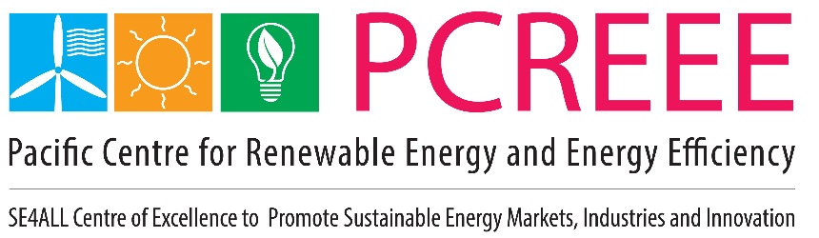

PCREEE Progress report

Date of report: 1st January – 30th June 2020

1. General overview on the activities conducted and achievements in the reporting period

A. Overall progress in the implementation of the annual work plan (later Business Plan):
The overall progress during the reporting period was generally satisfactory though the planned activities from March onwards were either rescheduled or postponed due to the covid-19 pandemic. As a result of the travel restrictions and border closures, the activities in the host country were easier to carry out. In order to ensure fair and equitable distribution of PCREEE support among members, PCREEE encouraged the National Focal Institutions to be more active and responsive and:

- coordinate local events
- send out PCREEE-drafted invitations to local stakeholders
- identify and utilise local expertise as necessary
- book venue and arrange for catering to be paid for by the PCREEE
- find venue with good internet connection and good Bluetooth speakers
A total of 430 people comprising of 183 (43%) students, 50 (11%) private sector / industry representatives, 155 (36%) community representatives and 42 (9%) government officials participated in PCREEE-sponsored events as follows:
Events | Officials | Students
- Vanuatu Consultation of its low emission land transport response plan | 10
- Inaugural meeting to establish the Sustainable Energy Association of Vanuatu | 12
- Tonga workshop on electrical safety and compliance | 30
- Regional zoom meeting on the draft e-mobility policy and programme | 30
- Joint OIREP and PCREEE workshops to Explore the Business Opportunities & Strengthening the Business Skills Capacity of Stakeholders in Ha’apai | 135  70M / 65F
- Joint OIREP and PCREEE workshops to Explore the Business Opportunities & Strengthening the Business Skills Capacity of Stakeholders in Vava’u | 20  12M / 8F
- PCREEE-TEC workshop on the fundamentals of price regulation as well as Price Regulation in the context of Tonga’s Electricity Concession Contract | 10
- PCREEE-EU PacTVET Joint Awareness and Promotion Campaign on SE Entrepreneurship and SE TVET – Mailefihi Siu’ilikutapu College, Vava’u |  | 51
- PCREEE-EU PacTVET Joint Awareness and Promotion Campaign on SE Entrepreneurship and SE TVET – Vava’u High School, Vava’u |  | 12
- PCREEE-EU PacTVET Joint Awareness and Promotion Campaign on SE Entrepreneurship and SE TVET – Tailulu High School, Vava’u |  | 67
- PCREEE-EU PacTVET Joint Awareness and Promotion Campaign on SE Entrepreneurship and SE TVET – Saineha High School, Vava’u |  | 53
TOTAL | 247 | 183

B. Progress concerning the establishment of the institutional set-up

Business Plan and e-Mobility Programme
Both documents are at an advanced drafts and consultations with stakeholders have begun.

3rd Anniversary
PCREEE celebrated its 3rd Anniversary in April. The event was marked with the following:

- Release of the PCREEE’s Third Year Progress Report - https://www.pcreee.org/sites/default/files/event/files/PCREEE%203rd%20Anniverssary%20Leaflet_final%20draft%20270420.pdf
- launch of the PCREEE Promotion and Public Awareness Campaign Strategy -https://www.pcreee.org/event/launch-pcreee-regional-re-and-ee-awareness-campaign-strategy
- Radio inteview and media release
Staff Regulations and Manual of Staff Policies
During the reporting period, SPC launched its Staff Regulations and Manual of Staff Policies and provided an opportunity to clarify any questions that staff may have. Zoom meetings were held in both English and French to further explain the manual to staff. The manual provides much more clarity and transparency in the interpretation and application of the regulations. It therefore promotes consistency and improved fairness in dealing with staff issues.

Staffing
A few movements in the staffing of the PCREEE took place during the reporting period, as follows:
- A NZ-funded Media and Communication Adviser (Ms Emma Carle) joined the PCREEE team early in January, only to be forced to be repatriated back to NZ in March due to the COVID-19 pandemic.
- An Autralian-funded intern (Mr Sarel Steinauer) completed his 9 weeks internship with the PCREEE in March, just as the Australian government called for the repatriation of its citizens due to the COVID-19 pandemic.
- A female and national of Papua New Guinea (Darlen Lovi) joined the PCREEE in March as the Pacific Island Junior Professional
- The secondment of the Eu-funded PacTVET In-country Cordinator (Mr Paea Tau’aika) was extended from April for another 6 months and continued to be housed at the PCREEE
- The recruitment of a Australia-funded Sustainable Energy Entrepreneurship Advisor and a NZ-funded Energy Efficiency Adviser got further postponed due to the uncertainties and reprioritisation brought by the COVID-19 pandemic.
Partnerships
Two MoUs were signed during the reporting period with:
- EcoCARE Pacific Trust – a NZ-based NGO working to empower the private sector, the business community and industries to play a more active role in the sustainable energy development of Tonga and the PICTs.
- University of Papua New Guinea and its Centre of Renewable Energy (CORE)
Resource Mobilisation Effort
- Started discussing with Austrian Development Agency about its future funding to the PCREEE
- Conducted 2 CTCN consultancies in Tonga & Vanuatu
- The PCREEE is assisting the EU-PacTVET project with the development of the Tonga National Qualifications on Sustainable Energy: Levels 1 – 4. PacTVET is being charged monthly based on time spend on the qualifications.
- PCREEE has also been approached by Coffey International Development Pty LTd to be its Pacific Specialist on a consultancy to conduct an evaluation of NZ’s Development Aid’s Energy Programme, including the Pacific Islands.
- A planned PCREEE-ISA submission to France’s One Planet summit was cancelled due to the COVID
Banking
The SPC Project Account in Tonga, which was specifically for the PCREEE, has now been made a SPC-wide account that is centrally managed from SPC Finance in Suva. All SPC payments in Tonga and made through this account and Suva charge them to the respective projects and donors.

At the same time, we have started using a petty cash fund to give us more flexibility and save time when dealing with small payments.

National Focal Institutions and Thematic Hubs
The PCREEE continued to work through the NFIs, noting the varying efficiencies and responsiveness. The SPC Suva office convened one meeting of the THs in Suva just to update each other on their respective activities.
Regular reporting to SPC
Monthly reports were produced for the monthly meetings of the Georesources and Energy Programme and sometimes PCREEE events were part of the weekly corporate report to the SPC Director General.

C. Progress concerning the of the technical program of the centre
The PCREEE continues to focus its effort to empower the private sector through the following initiatives:

Support to Energy Regulators to create the enabling environment for investment
- Continued with the delivery of a technical assistance to the Energy Regulator in Tonga (Tonga Electricity Commision-TEC) to support its negotiation with the Power Utility (Tonga Power Ltd) on its 3rd five-yearly Tariff reset 2020-2025 thereby promoting private sector investment in Tonga’s electricity sector.
- The TA has helped to build the capacity of the TEC in analysing and reviewing the basis and methodology of deriving the tariff cost variables proposed by TPL
- The TA has helped to train the TEC Board members and senior staff of TEC during a 2 half-days virtual workshop on the fundamentals of price regulation as well as Price Regulation in the context of Tonga’s Electricity Concession Contract.
- The TA has helped to factor in RE, for the first time, in the calculation of Tonga’s power tariff
- Discussions are underway for a regional virtual workshop for energy regulators on adressing renewable energy in the tariff calculations, using the Tonga experience.
Raise awareness to the business and employment opportunities in the Energy Sector
- A national energy dialogue was planned for American Samoa and the North Pacific but was postponed due to covid-19 pandemic
- Completed joint community workshops with the ADB-funded Outer Islands Renewable Energy Programme in Tonga to Explore the Business Opportunities & Strengthening the Business Skills Capacity of Stakeholders in Vava’u, Ha’apai & Niuatoputapu - https://www.pcreee.org/event/joint-oirep-pcreee-workshop-exploring-business-opportunities-strengthening-business-skills
- Completed joint school visits jointly with the EU-funded PacTVET project to talk to TVET student about employment opportunities and sustainable energy in general.
Establishment of Sustainable Energy Industry Associations
- Completed the meeting and the establishment of the Sustainable Energy Association of Vanuatu
- Completed a safety and compliance workshop for Tonga’s Associated Members of the Registered Electrical Contractors. Training was an assistance to the Cyclone Harold recovery (struck in April 2020) and the preparation for the covid-19 pandemic. See links below for the related media coverage - https://www.pcreee.org/article/tonga-electricity-commission-and-pacific-centre-renewable-energy-and-energy-efficiency & https://www.pcreee.org/article/tonga-improves-reliability-power-supply-health

PCREEE Sustainable Energy Entrepreneurship Fund
- Continued to liaise with the Solomon Is on upgradng the power system at the Atoifi Adventist Hospital.
- Assessed a submission from a company in the Solomon Is
- Adressed questions and interest from Vanuatu
PCREEE Sustainable Energy Research Support Fund
- Continued to support research of a PhD as well as a MA students

2. Detailed overview on outcome and output level based on the results framework in the project document (later business plan)

See next page
Outcome 1: Enhanced regional institutional capacities through the creation of the efficiently managed and financially sustainable Pacific Centre for Renewable Energy and Energy Efficiency (PCREEE)
Immediate Outcomes (short-term) - Outputs | Indicators | Baseline and Targets | Means of verification |  |  | Achievements so far | Indicated PCREEE budget in the work plan | Spent PCREEE budget | Raised co-funding  (indicate partners) | Comments
Output 1.1 The PCREEE Secretariat is physically established | - Office with appropriate space and equipment to accommodate the staff of the Secretariat | Baseline:  no regional RE&EE centre is in existence in PICTs;  Target(s):  - Office with appropriate space and equipment to accommodate the staff of the Secretariat | - Office space and invoices |  |  | - Level of Achievement: in %  96% | 21,500 | 10,199.32 |  | Bought a 16 GB Nikon camera plus 4 Lenovo laptops.  Already entered in the asset register.
Activities
1.1.1 Ensure the timely establishment of the PCREEE office infrastructure; operationalize the implementation of the committed co-funding of SPC, UNIDO and the Government of Tonga in line with the host country agreement;
1.1.2 Purchase of office equipment and establishment works in line with SPC and GoT procurement rules |  |  |  |  |  |  |  | 1093.13 for the 16GB Camera  9106.19 for the 4 Lonovo laptops |  | Including printery consumables
1.1.3 Rent and running costs for PCREEE office (to be covered by SPC and Government of Tonga) |  |  |  |  |  |  |  |  | In-kind support of approx. 15,000 | Rent, water, power and internet are paid directly by the GoT.
Immediate Outcomes (short-term) - Outputs | Indicators | Baseline and Targets | Means of verification |  |  | Achievements so far | Indicated PCREEE budget in the work plan | Spent PCREEE budget | Raised co-funding  (indicate partners) | Comments
Output 1.2 The Manager Director and the technical and administrative staff are recruited and the internal procedures and regulations are implemented | - Director Manager is appointed by SPC  - Technical and administrative staff is recruited in line with the commitments of SPC, GoT, UNIDO  - At least 4 local technical and administrative staff recruited  - Implementation of internal rules (e.g. procurement committee, financial and accounting rules) | Baseline:  no regional RE&EE centre is in existence in PICTs;  Target(s):  - Director is recruited  - At least four (4) technical and administrative experts are recruited  - Implementation of internal rules (e.g. procurement committee, financial and accounting rules) | - Staff contracts  - Internal rules documents |  |  | Level of Achievement: in %  99% | 93,739.13 | 127,192 | Tonga Govt is paying for the salary of 1 of its officers to work for PCREEE. SPC is paying for 30% of the Manager’s salary. NZ funded volunteer resigned after 2 months on the job. | Personnel costs for 4 PCREEE / SPC staff [Manager, Programme Delivery Officer, Pacific Island Junior Professional and Programme Assistant. Also included 20,000 for the consultancy on Tonga’s 3rd electricity concession contract reset.
Activities
1.2.1 Appointment of the PCREEE Manager Director by SPC in line with the established TORs and relocation to the PCREEE office in Tonga |  |  |  |  |  | 100% |  |  |  | Appointed in July 2018.
1.2.2 Recruit the administrative and technical PCREEE staff in accordance with the organizational chart and established ToRs (depends on availability of funds); UNIDO will be part of the selection committee; |  |  |  |  |  | 99% |  | 1948.85 |  | Recruited the PDO in June 2019, PA in Nov 2019, a  Media & Communication Adviser in Jan 2020 (NZ volunteer who resigned after 2 months) and a PIJP in March 2020.  Spend 1948.85 to bring an experienced PA from Suva to provide hands-on training on Finance, Admin & Procurement matters to the PCREEE’s PA.
1.2.3 Initial IT, HR, Finance & Admin support for the creation and implementation of the internal procurement, staff, travel, financial and accounting rules and procedures to approved in the first Steering Committee meeting |  |  |  |  |  | 100% |  |  | In-kind support of approx. 10,000 | GoT is providing the daily IT support for free. Admin, Finance and HR support is provided by SPC offices in Noumea and Suva and PCREEE is following established SPC rules and procedures.  Budget and spending represent SPC’s Project Management fee (15%)
1.2.4 Establish an internal quality and appraisal framework for renewable energy and energy efficiency supported activities
Immediate Outcomes (short-term) - Outputs | Indicators | Baseline and Targets | Means of verification |  |  | Achievements so far | Indicated PCREEE budget in the work plan | Spent PCREEE budget | Raised co-funding  (indicate partners) | Comments
Output 1.3 The institutional governance structure of the Centre are established and executed | - Number of NIFs and Thematic Hubs (TH) nominated  - Number of meetings of the Steering Committee and Technical Committee organized  - NFI network operational and Steering Committee formed | - Number of NIFs and Thematic Hubs (TH) nominated  - Number of meetings of the Steering Committee organized | - Host institution agreement  - Minutes of the SC  - NFI agreements |  |  | Level of Achievement: in %  97% |  |  |  | Completed the 4th Steering Committee Meeting in Dec 2019.
Activities
1.3.1 Sign and implement an Agreement for the Centre hosting |  |  |  |  |  | 100% |  |  |  | Signed in July 2017
1.3.2 Establish a network of National Focal Institutions (NFIs) and Thematic Hubs (THs) and develop their capacities |  |  |  |  |  | 97% | 15,000 |  | SPC conducted an in-house consultation on accessing GCF funds. | 15k was budgeted for a follow up workshop on resource mobilisation.
1.3.3 Organize the Steering Committee Steering Committee Steering Committee meetings as required |  |  |  |  |  | 100% | 15,000 |  |  | Completed the 4th Steering Committee meeting in Dec 2019. The 5th PSC meeting is planned for Nov/Dec 2020 and to be conducted virtually.
Immediate Outcomes (short-term) - Outputs | Indicators | Baseline and Targets | Means of verification |  |  | Achievements so far | Indicated PCREEE budget in the work plan | Spent PCREEE budget | Raised co-funding  (indicate partners) | Comments
Output 1.4 Long and short term planning, implementation and monitoring framework of the Centre is established and implemented | - 1 approved Business Plan by the Committee  - 1 work plan per year  - 1 Monitoring and Evaluation Framework tracking the PCREEE progress | Baseline:  no regional RE&EE centre is in existence in PICTs;  Target(s):  - 1 approved Business Plan by the Committee  - 1 approved work plan per year  - 1 Monitoring and Evaluation Framework tracking the PCREEE progress | - Business Plan and strategic environmental assessment (SEA)  - Annual work plans  - Monitoring and evaluation framework |  |  | Level of Achievement: in  %  80% | 15,000 |  |  | Several versions of the draft business plan have been shared and reviewed.  Virtual consultations with countries is planned for the second half of 2020 prior to the launch at the 5th PSC, and to be conducted jointly with the emobility consultations.
Activities
1.4.1 Development of the PCREEE Business Plan and ensure that the environmental impact of RE&EE measures, technologies, equipment and infrastructure is taken into account and duly reflected in the plan |  |  |  |  |  | 95% |  |  |  | Several versions of the Business Plan have been edited. Shared with ADA in terms of their future funding commitments to the PCREEE.
1.4.2 Development and adoption of annual work plans, status reports and audited financial statements of the Centre in line with SPC |  |  |  |  |  | 85% |  |  | PCREEE contributed to the auditing costs through the 15% PM fees. | Centre is annually audited together with all SPC accounts and projects.  Annual work plans and progress reports are adopted at the Steering Committee meetings
1.4.3 Develop and implement a monitoring and evaluation system including indicators measuring the PCREEE progress and impact |  |  |  |  |  | 80% |  |  |  | PCREEE is using the ProDoc Results Framework
Immediate Outcomes (short-term) - Outputs | Indicators | Baseline and Targets | Means of verification |  |  | Achievements so far | Indicated PCREEE budget in the work plan | Spent PCREEE budget | Raised co-funding  (indicate partners) | Comments
Output 1.5 The core activities and functions of PCREEE are implemented and sustainability of the organization is reached | - Number of established internal procedures and technical programs  - Number of NIFs and Thematic Hubs (TH) nominated  - Number of meetings of the Steering Committee  - % of business plan and annual work plans are implemented at the end of the first operational phase of PCREEE  - Volume of co-funding for the technical program of the centre raised | Baseline:  no regional RE&EE promotion agency in existence in PICTs;  Target(s):  - Number of established internal procedures and technical programs  - 22 NIFs and at least 5 Thematic Hubs (TH) nominated  - At least 3 meetings of the Steering Committee  - At least 70% of the business plan and annual work plans are implemented  - At least 5 million USD co-funding for the technical program of the centre raised | - Meeting minutes  - Project documents  - Annual work plans and progress reports of PCREEE |  |  | Level of Achievement: in %
Activities
1.5.1 Mobilize and sign a funding agreement with at least one additional PCREEE donor |  |  |  |  |  | 80% | 15,000 |  |  | Started the process to sign a SPC-ADA Contribution Agreement for 2021 – 2023.  Budgeted 15k for a follow up funding proposals development workshop (see 1.3.3 on ToR)
1.5.2 Sign at least 5 technical cooperation agreements with local (e.g. universities, institutions, training centres) and international partners |  |  |  |  |  | 90% |  |  |  | A planned PCREEE-ISA submission to France’s One Planet summit was cancelled due to the COVID pandemic. Signed MoUs with EcoCARE Pacific Trust and the Uni of PNG.
1.5.3 Develop at least 2 RE&EE PCREEE program/project proposals to be submitted for financing to international partners (e.g. GEF, GCF, CTCN) |  |  |  |  |  | 50% |  |  |  | Tonga Circular Economy Feasibility study & funding proposal development has started.  Vanuatu’s low emission land transport feasibility study & funding proposal development will start second half of 2020.  Proposal with UNDP on a Vanuatu Performance-Based Financing Facility has discontinued due to GCF policies.  Regrettably UNIDO has no further interest on the GEF CleanTech proposal.
1.5.4 Represent PCREEE in regional and international key events (travel costs) |  |  |  |  |  | 100% and on-going |  |  |  | Manager participated in the ISA-funded STAR-C workshop in Feb.
Immediate Outcomes (short-term) - Outputs | Indicators | Baseline and Targets | Means of verification |  |  | Achievements so far | Indicated PCREEE budget in the work plan | Spent PCREEE budget | Raised co-funding  (indicate partners) | Comments
Output 1.6 A special programme on gender and sustainable energy is established and integrated to the activities of the centre and the network of regional sustainable energy centres | - gender programme is approved to be included in the Business Plan by the Committee | Baseline:  No gender programme in the energy sector of the PICs.  Target(s):  - a gender programme become a permanent fixture in the business plan of the centre | - Business Plan  - Annual work plans  - Monitoring and evaluation framework |  |  | Level of Achievement: in %  70% |  |  |  | SPC gender proposal to the Canadian (CTIF) was approved and is implemented from Suva.
1.6.1 Develop the energy-gender programme of the PCREEE in the context of the “Island Women Open Network (IWON) for Sustainable Energy & Climate Resilience in Island Nations” |  |  |  |  |  |  |  |  |  | No interactions with IWON for a long time.
1.6.2 Submit the energy-gender programme to be endorsed by the SC |  |  |  |  |  |  |  |  |  | No need for the PCREEE to duplicate gender work of SPC in Suva.
1.6.3 Develop funding proposals for the energy-gender programme |  |  |  |  |  |  |  |  |  | Funding proposal to the Canadian was developed in SPC Suva.
1.6.4 Implement and continuously review to ensure consistency with the regional gender programme of SPC’s Social Development Programme and the “Island Women Open Network (IWON) for Sustainable Energy & Climate Resilience in Island Nations” |  |  |  |  |  |  |  |  |  | GBA Report by the CTIF project on clean energy sector analysis was circulated on 30/6/20 to PICs, DPs and CSOs for their comments.
Outcome 2: Strengthened capacities of local key institutions and stakeholder groups through the up-scaling and replication of certified training and applied research programs and mechanisms

Immediate Outcomes (short-term) - Outputs | Indicators | Baseline and Targets | Means of verification |  |  | Achievements so far | Indicated PCREEE budget in the work plan | Spent PCREEE budget | Raised co-funding  (indicate partners)
Output 2.1 A multi-year framework to strengthen the local RE&EE capacities of key institutions and stakeholder groups is developed, adopted and under implementation | - Regional capacity development  Strategy  - Implementation progress of the regional capacity development strategy in % of total | Baseline:  No regional capacity development strategy on RE&EE is in place; very weak implementation of  Target(s):  - Capacity development strategy is validated by key stakeholder groups (incl. women groups) and gender mainstreaming mechanisms are incorporated  - At least 30% of the activities of the regional capacity development strategy are implemented by end of the first operational phase of PCREEE. | 1. Capacity development strategy document  2. Mid-term review on program implementation |  |  | Level of Achievement: in %  50% |  |  |  | No budget allocated for this activity.  Capacity Development strategy was drafted and put aside given the strategic / master plan development and the need for PCREEE’s to complement what others’ are doing in this vast area.
Activities
2.1.1 Conduct a regional capacity needs assessment particularly reflecting the needs of the governments and local technology industry and business using existing studies and in cooperation with the NFIs (to be done in combination with activity 4.2.1 under output 4.2) |  |  |  |  |  |  |  |  |  | Various capacity needs and gap analysis have been conducted and offer sufficient guidance to the PCREEE
2.1.2 Develop a regional multi-year capacity development strategy particularly reflecting the needs of local public and private stakeholders (to be done in combination with activity 4.2.1 under output 4.2)
2.1.3 Produce tailored training and certification modules covering various RE&EE issues and tools in coordination with local business and industry groups (also in local language) |  |  |  |  |  |  |  |  |  | PCREEE has assisted to establish the Sustainable Energy Association of Vanuatu.
Immediate Outcomes (short-term) - Outputs | Indicators | Baseline and Targets | Means of verification |  |  | Achievements so far | Indicated PCREEE budget in the work plan | Spent PCREEE budget | Raised co-funding  (indicate partners) | Comments
Output 2.2 Pacific certification / accreditation scheme for individuals, organisations and products is created (in collaboration with SEIAPI) and operational | - Number of training competency standards are operational  - Number of training standards adopted by the centre  - Number of trainers certified across 22 PICTs  - Number of training institutions and universities adopt the competency standards | Baseline:  No regional competency standards, certification and accreditation schemes for trainers and training institutions are in place; no regional gender mainstreaming standards in place;  Target(s):  - At least 5 training standards adopted by the centre (at least on is dedicated to gender mainstreaming)  - At least 80 trainers are certified across at least15 islands (at least 30% are female)  - At least 5 training institutions and universities adopt the competency standards | - Competency standards documents  - Records of certified trainers |  |  | Level of Achievement: in % |  |  | Compensated by the PacTVET for 7942 for PCREEE’s inputs in the month of May. | PCREEE assisted the development of a national qualification on sustainable energy Levels 1-4 in Tonga through SPC’s PacTVET project.
Activities
2.2.1 Act as the secretariat for developing the training competency standards on RE&EE which was already started by USP/SEIAPI |  |  |  |  |  |  |  |  |  | This is a role better suited for a training institution and the industry, like USP and SEIAPI.
2.2.2 Act as the body accrediting training centres and certifying trainers |  |  |  |  |  |  |  |  |  | This is a legislated role of the National / Regional Qualification Authorities.
2.2.3 Act as the secretariat for co-coordinating installation and products standards/guidelines |  |  |  |  |  |  |  |  |  | The current development of the guidelines and standards is a bit messy.
Immediate Outcomes (short-term) - Outputs | Indicators | Baseline and Targets | Means of verification |  |  | Achievements so far | Indicated PCREEE budget in the work plan | Spent PCREEE budget | Raised co-funding  (indicate partners) | Comments
Output 2.3 Key stakeholders are trained by the certified trainers on RE&EE aspects of high relevance for the local business and industry sector | - Number of key stakeholders across 22 PICTs are trained by the certified trainers and/or institutions  - Number of the trained experts apply their received skills in the energy sector of PICTs | Baseline:  Weak capacities of key institutions and stakeholders in the energy sector (e.g. public institutions, utilities, banks, companies, consultants educational and research institutions); very weak mainstreaming of gender aspects;  Target(s):  - At least 800 key stakeholders across 22 islands are trained by the certified trainers and/or institutions (being at least 30% are female)  - At least 40% of the trained experts apply their received skills in the energy sector of PICTs (at least 30% are female) | - Attendance sheets and questionnaires  - Lists of participants  - Workshop documents |  |  | Level of Achievement: in %
Activities
2.3.1 Train key policy makers in sustainable energy policy planning and incentive mechanisms (including sustainable cooking and transport, equal access to renewable energy and the impacts of renewable energy installations on the environment) |  |  |  |  |  |  |  |  |  | National Energy Dialogues planned for American Samoa and the North Pacific get postponed due to the COVID pandemic.
2.3.2 Train utilities and regulators regarding RE integration/grid stability and energy efficiency (e.g. demand side management) |  |  |  |  |  |  |  |  | In-kind support of about 1,000 | Jointly conducted a electrical safety & compliance workshop with the Tonga Electricity Commission.
2.3.3 Provide targeted RE&EE business development training for clean-tech SMEs and entrepreneurs (e.g. energy auditors, equipment installers, RE service providers) |  |  |  |  |  |  | 30,000 |  |  | Allocated 30k for joint training activities with GEF-funded projects in PNG, Tuvalu and Vanuatu.  Implementation has been delayed by the COVID pandemic.
2.3.4 Increase the capacity of stakeholders to mainstream gender and climate resilience into RE&EE policies and projects |  |  |  |  |  |  |  | SPC Suva has got a gender project funded by the Canadians / CITF.  PPA is also into gender in the power sector, see https://www.ppa.org.fj/  gender-portal/
2.3.5 Increase the capacity of technical private-sector experts and start-ups to develop, install and maintain RE&EE projects and systems (including training on climate resilient energy infrastructure).
2.3.6 Train experts on the financial structuring, design and planning of RE&EE projects (e.g. climate finance, RETScreen, HOMER)
Immediate Outcomes (short-term) - Outputs | Indicators | Baseline and Targets | Means of verification |  |  | Achievements so far | Indicated PCREEE budget in the work plan | Spent PCREEE budget | Raised co-funding  (indicate partners) | Comments
Output 2.4 Applied science research networks and technology transfer with high relevance for the local business and industry sector are promoted | - Number of applied research programs receive funding and are under execution  - Number of RE&EE technology transfer projects are under implementation | Baseline:  No major regional applied research programs and technology transfer projects on RE&EE are under implementation;  Target(s):  - At least seven national research institutions are involved in the execution of at least (3) regional applied research programs on RE&EE  - At least two innovative technology transfer projects are under implementation (e.g. waste to energy, sustainable transport) | - Research reports  - Program documents  - Progress reports |  |  | Level of Achievement: in % | 10,000 |  |  | Hosted Uni student from Australia doing work experience placement and research RE. Spent quality time with the Tonga Power Ltd’s team and their RE installations.
Activities
2.4.1 Conduct a baseline study on the research priority needs of the Pacific RE&EE industry and business sectors
2.4.2 Create a regional incentive model for the establishment of regional research programmes with high relevance for the local industry (e.g. call for proposals) |  |  |  |  |  |  |  | 1550.87 |  | Spending is the reimbursement of 2 students’ research works in Tonga.
2.4.3 Promote south-south and north-south technology transfer programs and projects |  |  |  |  |  |  |  |  |  | CCREEE assisted with PCREEE’s webinar on emobility.
Outcome 3: The awareness and knowledge base of local key institutions and stakeholder groups on RE&EE are strengthened

Immediate Outcomes (short-term) - Outputs | Indicators | Baseline and Targets | Means of verification |  |  | Achievements so far | Indicated PCREEE budget in the work plan | Spent PCREEE budget | Raised co-funding  (indicate partners) | Comments
Output 3.1 An effective online RE&EE information management system addressing the needs of investors, private sector and industry is created and operating | - Number of national institutions in 22 PICTs provide updated RE&EE data to the system on an annual basis  - Number of documents, files and data-sets are available in the database  - Number of registered users visit the data system regularly and download data  - % of the responding users confirm their satisfaction with the quality and reliability of the data in annual online surveys | Baseline:  The current regional RE&EE information system is inadequate and lacks of reliability and relevance for the private sector and industry; currently there exists no systematic collection of sex-disaggregated baseline data;  Target(s):  - At least 22 institutions in 22 PICTs provide updated RE&EE baseline data to the system on an annual basis (sex-disaggregated data)  - At least 500 documents, files and data-sets are available in the system by end of the first operational phase  - At least 200 registered users (at least 50% of it from PICTs and represent private sector) visit the data system regularly and download data  - At least 70% of the responding users confirm their satisfaction with the quality and reliability of the data in annual online surveys | - web statistics |  |  | Level of Achievement: in % |  |  |  | The data management system of the Georesources and Energy Programme of SPC is conducted from Suva through its Pacific Regional Data Repository portal.  http://prdrse4all.spc.int/  SPC continued to liaise with the WB on a USD 7 million data proposal.
Activities
3.1.1 Establishment of the interactive PCREEE website (www.pcreee.org) and link it to the Global Network of Centres and the Pacific Regional Data Repository for SE4ALL |  |  |  |  |  |  |  |  |  | The PCREEE website is fully functional and regularly updated from both Suva and Tonga. Website is linked to the GN-SEC.
3.1.2 Compile an inventory of relevant experiences/projects and papers/study reports/research reports and documents on best practices, skills, know-how, knowledge, technology suppliers in each PICT (disseminated through the information system) |  |  |  |  |  |  |  |  |  | Linked the PCREEE website to the Pacific Regional Data Repository to form the PRDR-PCREEE Knowledge Hub, as seen in the Resources page of PCREEE’s.
3.1.3 Create a database of RE&EE stakeholders, including governments, training institutes, industry and NGO’s (to be disseminated through the information system) |  |  |  |  |  |  |  |  |  | Have started but not fully populated.
3.1.4 Develop guidelines on energy data verification, quality and harmonisation in cooperation with the NFIs |  |  |  |  |  |  |  |  |  | Worked with SPC Suva colleagues and UN ESCAP
3.1.5 Create a database of RE&EE standard investment opportunities for the region to facilitate matching available funds to real projects (particularly in alignment with the activities under outcome 4) |  |  |  |  |  |  |  |  |  | Have started but not fully populated.  Planned for an joint Investment Forum [matchmaking opportunity] in Fiji on the second half of 2020 and at the Solomon Is in 2021.
3.1.6 Produce and publish and RE&EE resource atlas and facilitate resource mapping in the PICTs (data to be disseminated through the information system) |  |  |  |  |  |  |  |  |  | Currently working with the UK-based Institute for Environment Analytics of the Uni of Reading to develop an online toolkit for solar and wind resource assessment and energy planning in Palau, Tonga and Vanuatu.  Producing a wind and solar atlas is a part of the PPA SEIDP - https://www.ppa.org.fj/seidp-background/solar-wind-resource-maps/
3.1.7 Map existing sustainable energy projects including their key information (manufacturer, installer, status of operation, generated energy, etc) and disseminate information through the information system |  |  |  |  |  |  |  |  |  | Have started but not fully populated.
Immediate Outcomes (short-term) - Outputs | Indicators | Baseline and Targets | Means of verification |  |  | Achievements so far | Indicated PCREEE budget in the work plan | Spent PCREEE budget | Raised co-funding  (indicate partners) | Comments
Output 3.2 Awareness and knowledge base of key stakeholder groups on various RE&EE aspects are strengthened | - Number of experts from the Pacific region participates in PCREEE RE&EE conferences by end of the first operational phase (at least 30% of the invited panellists are female)  - Number of PCREEE conferences with focus on the gender-RE&E nexus  - % of the population in 22 countries is reached by regional awareness RE&EE campaigns supported by PCREEE | Baseline:  Awareness of key stakeholders on RE&EE varies considerably across the Pacific islands; there is lack of awareness on gender-RE&EE issues;  Target(s):  - At least 400 experts from the Pacific region participate in PCREEE RE&EE conferences by end of the first operational phase (at least 30% of the invited panellists are female)  - At least one PCREEE conference will have a special focus on the gender-RE&EE nexus  - At least 25% of the population in 15 countries is reached by regional awareness campaigns | - Reports and statistics of audio-visual awareness raising campaigns  - Lists of conference participants |  |  | Level of Achievement: in %  Completed awareness activities in Tonga jointly with the OIREP, benefitting 155 people from communities & 183 secondary school students.  Supported the Tonga Power Ltd’s RE Seminar, attended by 30 people.  Ordered awareness and promotional materials which will arrive on the 2nd half of 2020. | 35,000 | 5907.67 | In-kind support from the OIREP of approx. 10,000 | Budgeted 35k for awareness activities in Tonga, Vanuatu, Solomon Is and the North Pacific to be conducted jointly during planned PCREEE events (dialogues & investment forums).  Spending is for the Tonga events only.
Activities

3.2.1 Organize at least one major annual conference on different RE&EE aspects |  |  |  |  |  | Discussions of a joint regional investment forum with GET.invest has not advanced any further.
3.2.2 Contribute to the production a RE&EE Industry report in cooperation with REN-21 and link the Pacific to the Asia-Pacific portal as well as the global tracking framework to the SE4ALL initiative |  |  |  |  |  |  |  |  |  | Participated as a panellist at a REN 21 event at ESCAP in Oct. No further contacts with REN 21.  SPC data work is led from Suva with support from the PCREEE.
3.2.3 Design and implement at least one regional RE&EE awareness campaign targeting the residential, commercial or industrial sectors |  |  |  |  |  | We have approached PICs for key annual national events (e.g national day celebration, tourism week, etc) where we can jointly conduct awareness / promotion activities. |  |  |  | Launched PCREEE’s Regional RE and EE Awareness Campaign Strategy during the 3rd Anniversary of the PCREEE.
3.2.4 Provide technical policy implementation to CROP agencies, especially to SPC, as well as Member States and the private sector and industry (task to be delegated by the SPC Energy Programme) |  |  |  |  |  |  |  |  |  | PCREEE’s work on policies is closely coordinated with SPC’s Policy and Governance team in Suva.
Outcome 4: Increased RE&EE business opportunities for local companies and industry through the development and implementation of regional investment promotion programs and tailored financial schemes
Immediate Outcomes (short-term) - Outputs | Indicators | Baseline and Targets | Means of verification |  |  | Achievements so far | Indicated PCREEE budget in the work plan | Spent PCREEE budget | Raised co-funding  (indicate partners) | Comments
Output 4.1 Investments in RE&EE projects are promoted | - Volume of investments (in USD) for the execution of the SIDS DOCK project pipeline mobilized  - Number of small to medium-scale RE&EE projects co-funded by national institutions (e.g. banks) with the support of newly created regional support schemes  - Investment volume (in USD) of developed (pre-)feasibility studies/energy audits for innovative RE&EE projects addressing industrial key sectors (e.g. tourism, agriculture, fishery, creative industry);  - Number of regional key programs to promote investments in innovative technology areas developed and under implementation (e.g. waste to energy, efficient transport); | Baseline:  Insufficient levels of RE&EE investments to reach the set SIDS DOCK and PICTs RE&EE targets by 2033. Lack of technical assistance and financing for the SIDS DOCK RE&EE project pipeline of USD 617 million; lack of tailored RE&EE financing instruments for small and medium sized RE projects and EE solutions; lack of RE&EE programs which target key industries in PICTs (e.g. food processing, fishery, manufacturing, tourism);  Target(s):  - At least 100 million USD for the execution of the SIDS DOCK project pipeline are mobilized by end of the first operational phase of PCREEE.  - National institutions (e.g. banks) in at least 7 countries co-fund 80 small to medium-scale RE&EE projects with support of newly created regional support schemes (schemes consider mainstreaming of gender and environmental safeguard standards)  - (Pre-)feasibility studies and energy audits for innovative RE&EE projects addressing industrial key sectors (e.g. tourism, agriculture, fishery, creative industry) with an investment volume of at least 60 million USD are developed and in the SIDS DOCK project pipeline included (considering environmental safeguard standards and gender mainstreaming)  - At least two (2) regional key programs to promote investments in innovative technology areas are developed and under implementation (e.g. waste to energy, efficient transport); | - Documents on support schemes (incl. environmental safeguard standards, gender mainstreaming)  - (Pre-)Feasibility studies  - Project documents  - Project progress reports  - Signed contracts  - Minutes of investment forums |  |  | Level of Achievement: in %
Activities
4.1.1 Establish a database of RE&EE priority investment projects in the residential, commercial and industry sectors presenting relevant project data (to be published through the Centre website) |  |  |  |  | PICs are going through their NDC enhancement exercises with the Pacific NDC hub. |  | 35,000 |  |  | PICs energy roadmaps and NDCs are not very specific on the needed investments and projects to reach their targets.  SIDS Dock, IRENA and ISA have each compiled a pipeline of projects from the PICs.  PCREEE National Energy Dialogues and workshops have highlighted the need to further elaborate on the national targets so as to more specifically identify the investment and employment opportunities.
4.1.2 Organize annual investment and business forums (e.g. trade fare) to present the project pipeline to interested financiers and investors |  |  |  |  | Planning a joint investment forum with PFAN in Fiji on the second half of 2020. |  |  |  |  | A national sustainable energy investment forum was planned for the Solomon Is has been moved to 2021.  A regional investment forum was planned for the second half of 2020 but is now postponed to 2021.
4.1.3 Raise funding for the pool of bankable RE&EE investment projects and provide preparatory and investment support for new projects (e.g. feasibility studies, elaboration of project proposals) in cooperation with existing mechanisms (e.g. SPREP, IUCN, ADB) |  |  |  |  |  |  |  |  |  | Tonga Circular Economy Feasibility study & funding proposal development has started.  Vanuatu’s low emission land transport feasibility study & funding proposal development will start second half of 2020.  Proposal with UNDP on a Vanuatu Performance-Based Financing Facility has discontinued due to GCF policies.  Regrettably UNIDO has no further interest on the GEF CleanTech proposal.
4.1.4 Design and testing of innovative RE financing schemes and business models for off-grid projects in cooperation with local banks (e.g. micro-credits) |  |  |  |  |  |  |  |  |  | Each PIC has tried their own financing schemes and financing models and the search for a sustainable model is an on-going activity.
Immediate Outcomes (short-term) - Outputs | Indicators | Baseline and Targets | Means of verification |  |  | Achievements so far | Indicated PCREEE budget in the work plan | Spent PCREEE budget | Raised co-funding  (indicate partners) | Comments
Output 4.2 The local sustainable energy industry is strengthened | - Adopted gender-sensitive PICTs strategy to promote local sustainable energy industry and entrepreneurship  - At least 150 local sustainable energy hardware and service companies in 22 PICTs receive financial support from the newly created regional facility (at least 30% are in the manufacturing sector). | Baseline:  Low local added value of RE&EE investments due to a lack of PICTs sustainable energy businesses and industry; lack of opportunities for local entrepreneurs due to the absence of tailored support instruments;  Target(s):  - Adopted gender-sensitive PICTs strategy to promote local sustainable energy industry and entrepreneurship  - At least 150 local sustainable energy hardware and service companies in 22 PICTs receive financial support from the newly created regional facility (at least 30% are in the manufacturing sector, at least 30% start-up companies).  - At least 20 companies in the sustainable energy sector are awarded through the established clean tech innovation program. | - PICTs strategy document  - Supported business plans of companies  - Financial documentation  - Project progress reports  - Documentation of call for proposals |  | Level of Achievement: in %  50% |  | 180,000 | 9244.76 |  | Spending relate to the meetings to establish the sustainable energy industry association in Vanuatu.
Activities
4.2.1 Undertake a baseline assessment and develop a PICTs strategy for the promotion of local sustainable energy businesses and industries in cooperation with PFAN and SEIAPI / the activity includes at least two private sector technical staff exchange and training visits |  |  |  |  |  |  |  |  |  | PFAN has finally shown some interest to work with the PCREEE.  PCREEE has a Sustainable Energy Entrepreneurship Facility and has received 2 expressions of interests from the Solomon Is and Vanuatu.
4.2.2 Work with PFAN and other partners on the potential opening of a call for proposal window for PICTS (e.g. to promote local RE&EE businesses and start-ups, investments) (to be implemented in combination with activity 2.3.3 under output 2.3) |  |  |  |  |  |  |  |  |  | PFAN has finally shown some interest to work with the PCREEE.
4.2.3 Develop and execute a clean-tech program to promote RE&EE business innovations (including prize competition for the most innovative business idea) - (to be implemented in combination with activity 2.3.3 under output 2.3 and output 3.1) |  |  |  |  |  |  |  |  |  | PCREEE has a sustainable energy innovation competition but no serious taker yet. PCREEE and UNIDO were working on the GEF CleanTech proposal but is now dropped.
4.2.4 Collect lessons learned and develop a manual for sustainable energy start-up companies (to be used in the trainings under output 2.3) |  |  |  |  |  |  |  |  |  | Similar business start up training has been conducted in Tonga for fruit pickers returning from Aust. Development of the manual has been disrupted due to the resignation of the officer responsible for this activity.

3. Achievements on impact level towards the indicators in the project document (later business plan)

Development Impact (ultimate outcome) | Indicators | Baseline and targets | Means of verification | Achievements
Improved access to modern, affordable and reliable energy services, energy security and mitigation of negative externalities of the energy system (e.g. local pollution and GHG emissions) by promoting renewable energy and energy efficiency investments, markets and industries in PICTs. | - % increase of people [urban and rural and disaggregated to males, females and children] with access to modern, reliable and affordable energy services provided by RE technologies (urban and rural population, sex-disaggregated data - baseline 2013)  - % increase of the RE contribution to the electricity mix of the PICTs (baseline 2013)  - Increase of investments in RE&EE projects in PICTs (% of it addressing key industries in PICTs - baseline 2013) in USD  - % decrease of fossil fuel import spending in PICTs due to the introduction of RE&EE technologies and solutions in USD (baseline 2013)  - % decrease of GHG tCO₂ emissions through implemented RE&EE projects  - Number of additional jobs created directly or indirectly in the RE&EE sector in PICTs  - % increase of registered local companies in the RE&EE sector | Baseline:  High energy costs hamper the socio-economic and industrial development in PICTs; high fossil fuel import spending in many islands; low productivity and competitiveness of local key industries due to energy costs (e.g. food processing, manufacturing of niche products, fishery, tourism); low levels of RE&EE investments; lack of local energy companies;  Target(s):  - 10% increase of people with access to modern, reliable and affordable energy services provided by RE technologies (urban and rural population, sex-disaggregated data - baseline 2013)  - 10% increase of the RE contribution to the electricity mix in PICTs (baseline 2013)  - USD 100 million of additional investments in RE&EE projects (at least 25% of it are addressing key industries in PICTs - baseline 2013)  - 10% decrease of fossil fuel import spending in PICTs due to the introduction of RE&EE technologies and solutions (baseline 2013)  - 15% decrease of GHG tCO₂ emissions through implemented RE&EE projects  - At least 100 additionally (directly or indirectly) created local jobs in the RE&EE sector (baseline 2013)  - 10% increase of registered local companies in the RE&EE sector (at least 25% of them are in the manufacturing sector) | - ESCAP’s report on Asia-Pacific Progress on the SDGs 2020.  - SPC’s meeting paper (E1) to the 4th Pacific Energy Ministers Meeting in Sept 2019.  - IRENA RE Energy Statiscis 2020  - Trade reports and National Communications to the UNFCCC COP.  - National Communications to the UNFCCC COP.  - Energy Sector Annual reports and Labour and Employment reports  - Business registration reports. | - ADB’s Pacific Energy Update 2019 and the statistics on the access to electricity, can be seen in the table below: 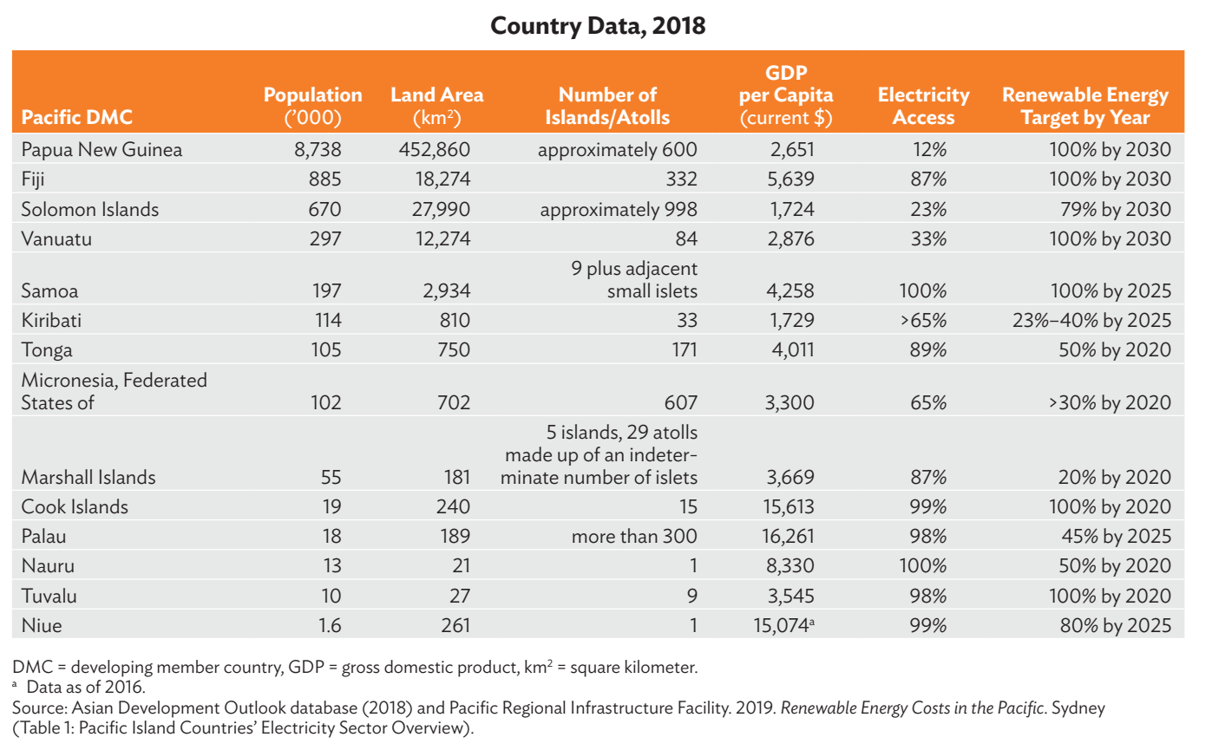  2. Between 2010 and 2019, around 912 MW of RE capacity has been installed in the PICs. Growth is obviously slow, as in the ESCAP SDG Progress report 2020. RE Capacity installed in the region from 2010 – 2019 can be seen in the table below:  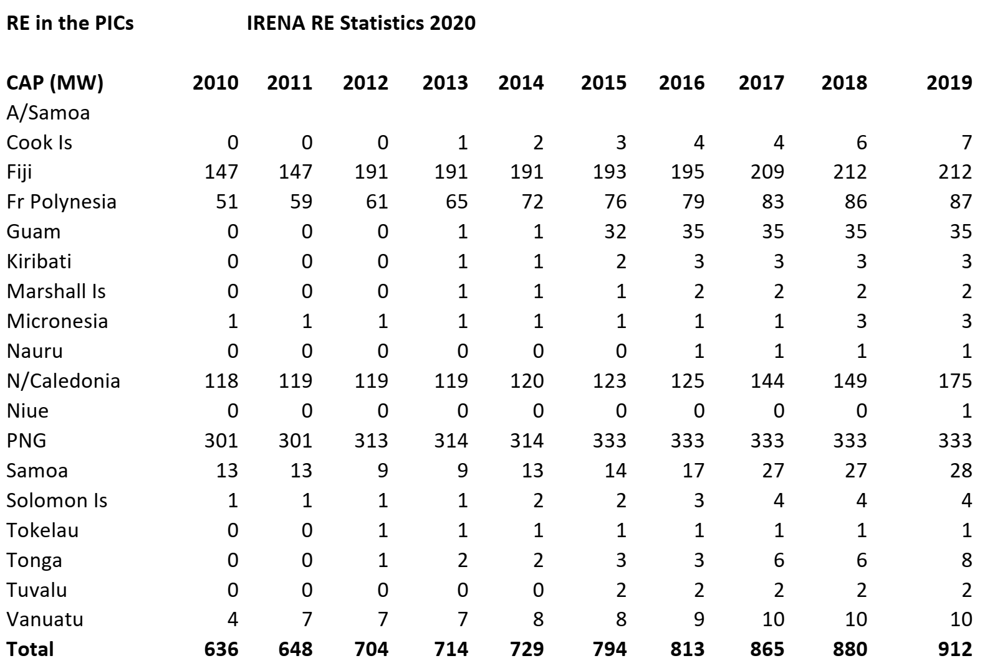  3. Some notable increases in investments on RE between 2018 – 2019 can be seen in the Cook Is, French Polynesia, New Caledonia, Niue, Samoa and Tonga.  4. Various estimates of the reduction in fossil fuel use per installed project have been made but most projects are not of a scale which can reduce fuel imports at the national level.  5. UN ESCAP’s SDG Progress Report for Asia and the Pacific (2020) showed that the Pacific has lagged behind other subregions on climate action (Goal 13) measured by emissions and the impact of disasters. The Pacific subregion needs to strengthen its effort to combat climate change. Measured in terms of carbon dioxide emission from fossil fuels per capita, the Pacific subregion is the worst performing subregion in the Asia- Pacific region at 11.1 tons of carbon dioxide per capita annually or more than double the regional average (in part due to the high level of emissions from developed economies in the subregion). The good news is that the subregion has reduced that figure from more than 13 tons per capita in 2005 and can hope to accelerate this progress. On the Goal 7 indicators, the Pacific need to accelerate progress on 5 out of the 6 while 1 (7.a) cannot be measured.  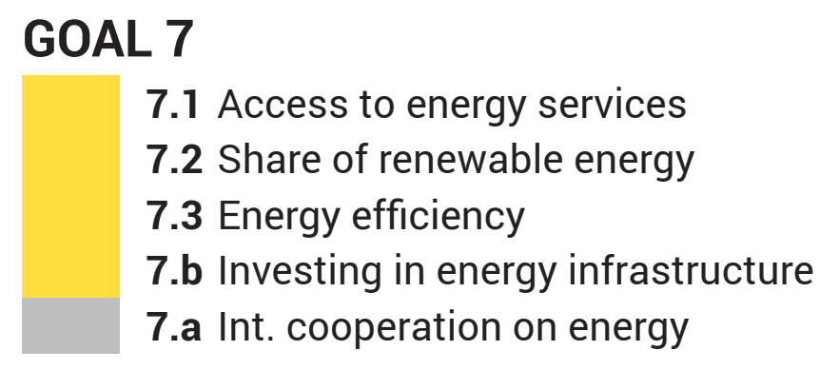  6. There has been an increase in the number of additional jobs in RE and EE, particularly in the countries with additional capacity and investments, see #3 above.  7. No doubt there has been some very small increases in newly registered energy businesses throughout the region but yet to be captured accurately.  With the current effort on NDC enhancement and the corresponding development of NDC Mitigation / Investment Plans, it would help to more effectively market the opportunities to start up new businesses on sustainable energy.

4. Main problems and constraints encountered and counter measures taken:

- COVID-19 Panedemic
The pandemic has been a challenge in terms of delivering the work programme. Border lockdowns began in March and is still continuing in most PICs. Some activities that were supposed to be delivered on the ground has been postponed. These include national energy dialogues in American Samoa and the North Pacific, an investment forum in the Solomon Is as well as regional workshops to validate and adopt the PCREEE business plan and e-mobility programme. A follow up workshop on developing funding proposals have been postponed too.

The NZ-funded volunteer and the Australia-funded intern were both repatriated due to the pandemic.

On the other hand, the pandemic has offered an opportunity to do business differently by way of virtual meetings and trainings. This is has obviously saved a lot on travelling costs.

PCREEE continued to be guided by SPC’s corporate direction on keeping staff and their families safe, including flexible working from home arrangements, flexible home leave and the encouragement of staff to take their annual leave and a break from their routines.

- Ineffective National Focal Institutions and Thematic Hubs arrangement
As mentioned in the July – December 2019 progress report, the energy landscape of the Pacific Islands is rapidly changing and is quite different to the environment during the development of the PCREEE ProDoc. Other related entities such as the Pacific’s Maritime Technical Cooperation Centre, the Pacific NDC Hub, the Pacific Climate Change Centre at SPREP, the Global Green Growth Institute and the International Solar Alliance have all emerged and will contribute, in one way or the other, to renewable energy and energy efficiency in the region. Each of these are operating in relation to an international, regional and national framework regarding either transport, energy and climate change.

The National Coordinators and national focal institutions in some are just the same with the PCREEE NFIs and Thematic Hubs, there is certainly a lot of work expected of these officials and institutions with their limited capacity. The NFI and THs arrangement for the PCREEE is working but could be working better and more effectively because of the competing demands from closely related institutions that the member countries and institutions are working with. People therefore become very selective on who they work with according to their own respective criteria and preferences.

- Need to better align the PCREEE to SPC’s Georesources and Energy Programme (GEP)
The Geoscience Energy Maritime Division of SPC has released its Business Plan. This was a timely development, allowing PCREEE’s to ensure its Business Plan and consistent with the division’s.

SPC’s Georesources and Energy Programme (GEP) is currently developing the new regional sustainable energy framework with new coordination mechanisms. It has also developed a Fundraising Strategy and is currently conducting a fit-for-purpose review of the GEP. At the same time, the PCREEE is developing its Master Plan and a regional e-mobility policy and programme.

- The PCREEE is understaffed in terms of numbers and the levels of expertise and experiences.

While the PCREEE challenge on staff numbers was improved by the Australia and NZ-funded volunteers, regrettably the pandemic meant that they had to be repatriated, leaving a gap in the PCREEE staff capacity.

The other option would be to have an additional PCREEE-paid Pacific Island Junior Professional positions in addition to the existing 3 professional staff and 1 support staff. The challenge is to have a team with the required skill sets but still be able to have a budget with a good balance between personnel and operations.

Both the PCREEE Strategic Plan exercise and the GEP review should provide some indication of the optimum staff levels at the PCREEE.

5. Proposed way forward:

It will take a while before the world can safely come out of the COVID 19 pandemic. The PCREEE has prepared to deliver its services virtually. The challenge is to get the local counterparts energised and motivated to effectively coordinate local events. At the same time, the PCREEE must assist to being local participants together.

Furthermore, PCREEE is going to open its virtual national events to others from the region who may be interested in the same event. For instance, PCREEE will support a virtual workshop on Power Tariff Resetting with the Tonga Electricity Commission. The PCREEE will open the event to others who may interested in the topic from throughout the region.

6. Financial implementation of the work plan:

Please find the financial snapshot enclosed.

7. Attachments:
- Signed Financial Report
- Update on the progress with the To

Report prepared by:
Manager - PCREEE:
__________________________________
Tonga, 10 August 2020

The budget and work plan is based on the work plan and budget approved at the 4th Steering Committee Meeting and included in the SPC & UNIDO agreed ToR attached to the signed Contract 4 (Amendment 2).
SIDS DOCK Goals by 2033: increase EE by 25 percent; generate a minimum of 50 percent of electric power from RE sources; 20-30 percent decrease in liquid petroleum transportation fuel use;

