Project Costs for Renewable Generation Projects in the Pacific (Webinar)

19 May 2019
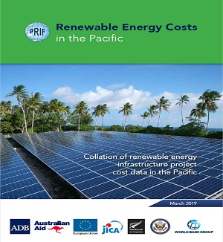
19 May 2019 United States
9:00 p.m. Eastern Daylight Time | 6:00 p.m. Pacific Daylight Time
20 May 2019 Manila, Philippines
9:00 a.m. Philippines Standard Time
20 May 2019 Tokyo, Japan
10:00 a.m. Japan Standard Time
20 May 2019 Canberra, Australia
11:00 a.m. Australian Eastern Standard Time
Check your local time.
Register now at https://attendee.gotowebinar.com/register/7218708750011792395.
The Clean Energy Solutions Center, in partnership with the Pacific Region Infrastructure Facility (PRIF) is hosting this webinar titled, Project Costs for Renewable Generation Projects in the Pacific. In a report published last month — Renewable Energy Costs in the Pacific — PRIF analyses the capital costs of large solar photovoltaic, wind and hydro generation projects built in the Pacific over the past decade. The study focuses on capital costs, while the importance of operation and maintenance costs and the levelised cost of electricity are acknowledged.
The large range of project costs for renewable generation projects in the Pacific is due to various factors, including remoteness, scale, local capacity, perceptions of risk, design parameters and any upgrades for existing infrastructure included in the project scope. There are numerous challenges in obtaining cost breakdown data and making like-with-like comparisons. The webinar will focus on the key overall findings from the PV systems analysis but will provide general analysis of the system cost breakdowns obtained for the report, which provides useful insights for component and other costs.

