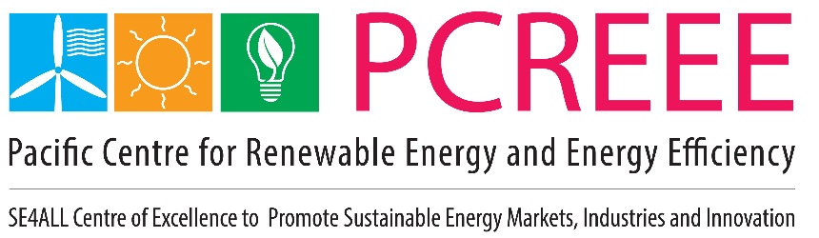

PCREEE Progress Report

**January – June 2024**

This Progress Report is specially prepared for the Austrian Development Agency (ADA). It is based on the overall progress of the PCREEE with special emphasis on the PCREEE’s sustainable mobility and sustainable mini-grid systems – the two focus areas of the PCREEE that is financially supported by the ADA.

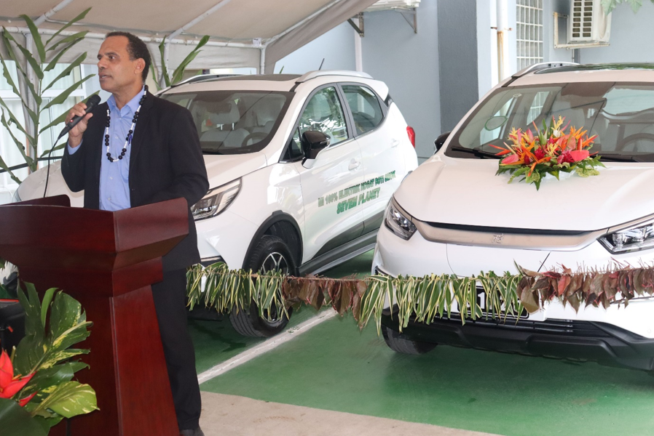

**Launching of the first electric cars in the Vanuatu government fleet (July 2024)**

**Abbreviations**

ADA Austrian Development Agency

BRANTV Barrier Removal for Achieving the National Energy Road Map Targets of Vanuatu (GEF-funded)

CAMCO Specialist Climate and Impact Fund Manager

EV Electric Vehicle

FESRIP Framework for Energy Security and Resilience in the Pacific

GHG GreenHouse Gas

ISA International Solar Alliance

LEDS Low emission development strategy

MoU Memorandum of Understanding

NCSE National Certificate on Sustainable Energy

NDC Nationally Determined Contributions

PacTVET The European Union’s Pacific Technical and Vocational Education and Training on Sustainable Energy and Climate Change Adaptation (PacTVET)

PCREEE Pacific Centre for Renewable Energy and Energy Efficiency

PICs Pacific Island Countries

PNG Papua New Guinea

PRIF Pacific Regional Infrastructure Facility (PRIF)

PRO SPC Polynesia Regional Office

ProDoc Project Document

SPC Pacific Community

STAR-C Solar Technology and Application Resource Centre (ISA)

TA Technical Assistance

TERM Tonga Energy Road Map

**Date of report**: 1st January – 30 June 2024

**GENERAL OVERVIEW ON ALL THE ACTIVITIES CONDUCTED AND ACHIEVEMENTS IN THE REPORTING PERIOD**

**A. OVERALL PROGRESS IN THE IMPLEMENTATION OF THE ANNUAL WORK PLAN:**

The overall progress during the reporting period was generally satisfactory.

A summary of PCREEE’s achievements in its five Outcome Areas are highlighted below:

**Outcome A: Effective and Efficient Management and Operation of PCREEE**

* Circulated the draft minutes of the 8th PCREEE Steering Committee Meeting in 2023
* Produced monthly progress reports to the management team of SPC’s Georesources and Energy Programme
* Maintained monthly updates of the PCREEE Asset Register and Petty Cash
* Completed a soft celebration of the PCREEE 7th Anniversary and launched PCREEE’s 7th Annual Report and awareness materials
* Continue to co-locate with the SPC Regional Office for Polynesia (PRO).
* The Programme Assistant for the PCREEE resigned. Began the recruitment of an Admin Assistant to be shared between the PCREEE and PRO.
* Tonga finally countersigned the Amendment to its Memorandum of Agreement with Tonga on the PCREEE, extending the collaboration for another 6 years period from 2024 – 2030
* Attended the 4th International Conference of the SIDS at Bermuda and Antigua and participated in a side event of the Global Ocean Energy Alliance and the Third Meeting of the Island Women Open Network (IWON) Committee.

**Outcome 1: RE&EE Business Start-Up and Entrepreneurship Support**

* Joint INFRATEC-PCREEE workshop on business skills and productive uses of energy training for community members in Kotu and ‘O’ua 29 Feb – 1 March 2024
* Conducted joint PCREEE - the Nationally Determined Contribution (NDC) Hub consultation meetings in the RMI as part of a coherence review of the RMI National Energy Policy and Action Plan (NEPAP 2015).
* Continued works to get more trained youths into the market by upgrading the documentations on the sustainable energy qualification Levels 1 – 2 in Tonga and the delivery of Level 3 and at the same time develop Levels 4 & 5 to achieve a Diploma.
* Continued to collaborate and promoted CAMCO, as per the MoU signed with SPC, and its works on developing the “Transforming Island Development through Energy and Sustainability” (“TIDES”) platform. TIDES is a blended finance platform for the Pacific aimed at providing flexible financing to local renewable energy developers with the goals of catalysing investment in zero-emissions projects across the full range of sizes, from mini-grids to large grid-connected systems. PCREEE lined up CAMCO to present the TIDES in its side event during the 53rd Pacific Leaders Meeting and to a National Energy Summit in the Solomon Is.
* Completed the solar freezer project for the Solar Freezer Project for the Tookina Tribal Land Conservation Association (TTLCA) in the Solomon Islands. Project was funded from the PCREEE Sustainable Energy Entrepreneurship Facility.

**Outcome 2: RE and EE for Sustainable Mobility**

* Supported the finalisation and publication of the Electric Vehicles Standards for the Pacific Islands by the Pacific Regional Infrastructure Facility. Started planning to conduct a regional workshop during the second half of the year to familiarise PICs and agencies with the published standards.
* Delivered a Technical Assistance to the Cook Is to strengthen the power utility’s (Te Aponga Uira) e-mobility effort

**Outcome 3: Sustainable mini-grid systems**

* Completed a joint workshop by USAID - Arizona State University – PCREEE – GGI and UNDP, Department of Energy and the Fiji Rural Electrification Fund on Accelerating off-grid electrification in the Pacific Islands on 20 & 21 June in Suva.

**Outcome 4: Energy Efficiency Investment**

* Conducted a workshop on operationlising the Minimum Energy Performance Standards and Labelling (MEPSL) regulation at the international port of Noro Provinve of the Solomon Is.
* Supported the SPC team in Suva is developing a Phase 2 funding propoosal to the Phase 2 of the Pacific Appliance Labelling and Standards programme.

**Social, Gender and Environment Considerations**

Gender, Equality, Diversity and Social Inclusion (GEDSI) considerations were always incorporated in the events and reporting of the PCREEE. The PCREEE is now better positioned to address GEDSI in its work plan and activities.

The Pacific Energy and Gender Strategic Action Plan (PEGSAP) was adopted and used by the Georesources and Energy Programme of SPC, including the PCREEE in 2022. Following the adoption of the Pacific Energy Gender Initiative (PEGI) Regional Steering Committee by the 5th Pacific Energy and Transport Ministers Meeting of 2023, a Project Manager for the PEGSAP was recruited with funding from the USA government. The PCREEE has linked the gender arm of the global network of Sustainable Energy Centres (the Global Women’s Network fo the Energy Transition - GWNET) to the PEGSAP and with the understanding that the PCREEE will not have a separate energy and gender programme.

For SPC’s recruitments, the **Recruitment principles** are applied – SPC’s recruitment is based on merit and fairness, and candidates are competing in a selection process that is fair, transparent and non-discriminatory. SPC is an **equal-opportunity employer**, and is committed to cultural and gender diversity, including bilingualism, and will seek to attract and appoint candidates who respect these values. Due attention is given to gender equity and the maintenance of strong representation from Pacific Island professionals.  If two interviewed candidates are ranked equal by the selection panel, preference will be given to the **Pacific Islander**. Applicants will be assured of complete confidentiality in line with SPC’s private policy.

For the environmental considerations – the PCREEE has tried this and mostly in relation to the catering to its events. It worked very well in Fiji where there are more established catering companies and they have the resources. It also worked well to some extend in Tonga and the Cook Is. For a lot of the caterers,  they find it most easy and convenient to put food in plastic bowls, plastic spoons and forks and give out  bottled water instead of water from jars.

For small events with 10 and less people, it was extremely hard to find a caterer who would not use plastics.

**B. PROGRESS CONCERNING THE ESTABLISHMENT OF THE INSTITUTIONAL SET-UP**

The PCREEE continued to function under the guidance of its Steering Committee. It is however noted that with the rapid staff turnover in the PICTs and competing work and other travel demands, continuity and consistency in the representation and attendance at the committee meetings was a challenge. It is extremely difficult to continuously follow-up on the updates of the official nomination for the National Focal Institutions and Thematic Hubs.

Staff Regulations and Manual of Staff Policies

SPC continued to update and modernize its policies and regulations relating its staff and their employment conditions.

During the reporting period SPC adopted a Flexible Working Arrangements Policy whereby the

Director-General may approve temporary or one-off arrangements that allow a staff member to work from home or other remote locations (other than when on official travel) or another organisation’s office, where it is in the best interests of SPC and of the staff member. Under this policy, the Director-General also has the capacity, in the interests of staff well-being and safety, to direct a staff member to work from home. The Director General may require the staff member to work from home until such a time that the Director-General determines that the staff member is able to return to work in SPC offices without risk to that staff member or to general staff well-being.

Staffing

The contracts of the two Pacific Energy Professionals (PEPs) were completed in November 2023. They then resumed duty at the Department of Energy in Tonga but one is on study leave abroad and one was still based from the PCREEE and assisted with the delivery of PCREEE-supported activities in Tonga and in the region.

Under the French-funded Solar Technology and Application Resource Centre (STAR-C), jointly managed by the International Solar Alliance and UNDIO, a Coordinator for the Pacific Islands was recruited and housed at the PCREEE. The PCREEE was selected as one of the three centres in the GN-SEC to be assisted with a Regional Qualification framework and a Quality Infrastructure framework on solar technology. Regrettably the Coordinator resigned in May and a replacement is yet to be confirmed.

Partnerships

The PCREEE participated in side events organised by SIDS Dock and the Global Ocean Energy Alliance at the margins of the SIDS 4 at Antigua and Bermuda.

Jointly conducted the Regional Workshop on Accelerating Off-grid electrification in Pacific Island Countries with the USA, Arizona State University, USP, UNDP, the Fiji Rural Electrification Fund and GGGI.

PCREEE participated in an advisory role in the organisation of the 2024 Oceania Renewable Power Summit, to be held in September 2024.

A Letter of Agreement was drafted and to be signed with the Tonga National University. Lawyers at SPC commented on the draft and this is to be finalised to be signed during the second half of 2024

Banking

PCREEE continued to work under the Suva-centralised banking systems and its petty cash fund – so far so good.

National Focal Institutions and Thematic Hubs

The PCREEE continued to work through the NFIs, noting the varying efficiencies and responsiveness.

PCREEE continued to liaise with the Thematic Hubs, especially the Pacific NDC Hub, SPREP and the Pacific Islands Development Forum where it has established joint activities with them. PPA and USP are mostly liaising with the Suva-based team of the SPC Georesources and Energy Programme where they cover the broader energy agenda and including the PCREEE too.

Regular progress reporting to SPC

There was a change in the Management of the SPC Energy Programme during the reporting period. The regular reporting continued but not on a monthly basis as before, however, the PCREEE continued to provide key highlights which went to the bi-weekly reports to the Director General.

The Co-location with the SPC Regional Office for Polynesia

The PCREEE continued to be co-located with the SPC Regional Office for Polynesia and there is a much improved decoration and the physical appearance of the office.

**C. PROGRESS CONCERNING THE TECHNICAL PROGRAM OF THE CENTRE**

The PCREEE continues to focus its effort on empowering the private sector through the following initiatives:

**Business Start-ups and Mentoring**

PCREEE’s support in this KRA were in these strategic areas:

**Training on business skills and the productive uses of energy**

Jointly conducted workshops on business skills and PURE with INFRATEC at the islands of ‘O’ua and Kotu in Tonga**.** Workshops were aimed at:

1. Improving awareness of appliances and electrical equipment that can be used to support businesses or entrepreneurship activities in the islands;
2. Improving the business skills and awareness about sustainable energy business start-ups;
3. Raising the awareness on possible small-scale business opportunities and available subsidies to assist with the recovery from the tsunami.

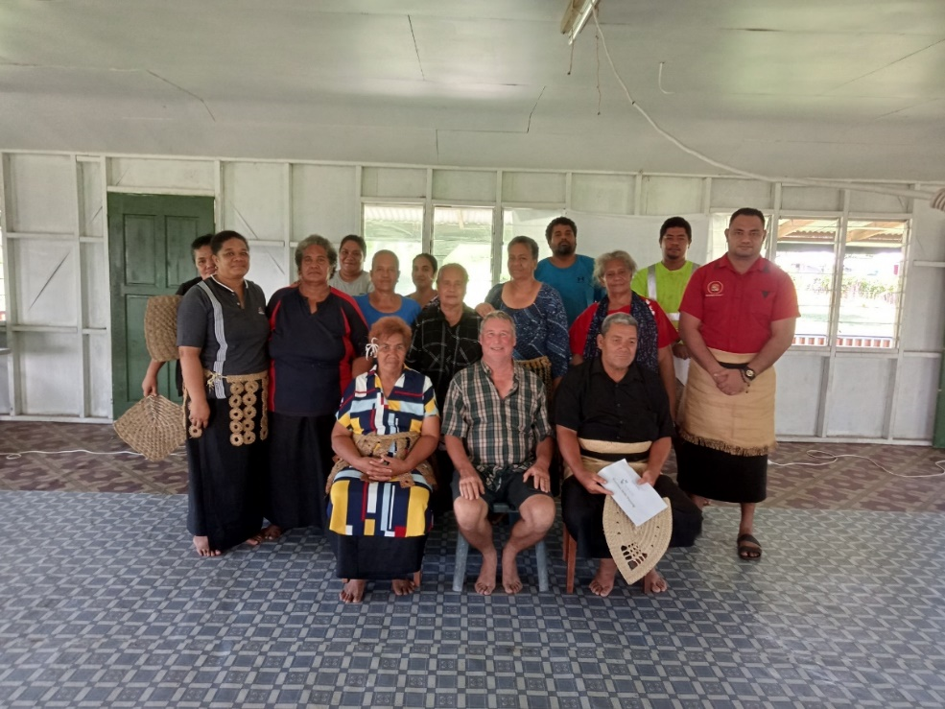

**Figure** - Outer islands participants at the joint IFRATEC-PCREEE workshop on Business Skills and the Productive Uses of Energy

**Support to Energy Regulators to create the enabling environment for investments.**

* The Office of the Pacific Energy Regulators’ Alliance (OPERA) is fully functional with the SPC Energy Programme in Suva and delivered technical support to the Regulators.
* Kiribati is now a member of OPERA.
* SPC has received fundng support to the OPERA from the UK government and will advertise for an OPERA Coordinator on the second half od 2024.

**Establishment of Sustainable Energy Industry Associations**

* Prepared for a Test and Tag training for the National Eelectrical Contractor’s Association of Tonga or NECAT. Trainers in NZ were identified and confirmed but members of the NECAT were not willing to buy their own tag meters to use at the training and then use in their respective businesses afterwards.

**PCREEE Sustainable Energy Entrepreneurship Fund**

* Completed a Solar Freezer Project for the Tookina Tribal Land Conservation Association (TTLCA) in the Solomon Islands. The total cost was SBD 42,500 and the PCREEE provided a subsidy of 12,750. The Immediate Impacts were reported to be:
* The solar freezer system provided the opportunity for the rural women to engage and make profit out of their fisheries project.
* The rural women were trained on how to use the solar freezer system to ensure its durability and maintain storage purpose.
* Women , girls and youths were engaged in the project to ensure inclusivity and equal participation.
* The rural women saving scheme is fully operational as the money earned is saved for future needs and unforeseen circumstances such as disasters and pandemics.

The Long-term Impacts were reported to be:

* Rural women are empowered with the micro economic skills and business development ideas that will enhance their income capacity and build assists for themselves.
* Rural women will be less dependent on their spouses hence, enhance opportunities for them to take up leadership roles and make important decision within the Community.
* Rural women saving scheme will foster solidarity and mutual support amongst the members of the saving scheme. Through this saving group, women can work together to mitigate any risk together collectively, such as establishing emergency funds or insurance mechanisms to cope with disasters and other problems.
* TTCLA is looking forward to acquire additional support for 2 or 3 solar freezer systems to encourage more women to participate in micro-fisheries income activities. The target is to provide fresh fish supplies to meet the consumer’s demand in hotels and restaurants in Honiara.

The project highly reccommended that PCREEE should increase the cost sharing arrangement to around 50% of the total cost of the solar freezer . The challenge faced by Community based organisations like TTLCA in acquiring funds is enormous thus, sometimes beyond the financial strength of the village dwelling people. Therefore, additional support is needed before such project can be successfully implemented. This can hinder rural people from acquiring such necessary project to improve their wellbeing and livelihood. Apart from that, it is highly reccommended if other assistance could be rendered in terms of business and hand set skill trainings to enhance local women’s capacity to effectively manage their fisheries business initiative to ensure its growth and sustainability. This will enhance rural women financial skills and literacy level to effectively manage their small business under this project assistance.

**Adoption of accredited qualifications on Sustainable Energy**

* The National Certificate on Sustainable Energy Level 3 on Solar and Energy Efficiency was completed and approved to be registered in the Tonga National Qualification Framework.
* Commenced developing NCSE Levels 4 & 5 as part of the STAR-C project so that a Diploma can be offered in Tonga and provided a pathway for sudents to pursue a degree.
* The Levels 4 & 5 in Tonga are planned to be used in updating the regional qualification framework, hosted by SPC’s Educational Quality and Assessment Division.
* The STAR-C Coordinator resigned in May and a replacement is yet to be identified and come on board. This has slowed down the development and delivery of the qualifications.
* Drafted a Letter of Agreement with the Tonga National University to allow its staff to review the Levels 1 - 3 documentations and to deliver Level 3. This is expected to be signed on the second half of 2024.

**E-mobility**

The work completed in this KRA included:

* Supported the Pacific Regional Infrastructure Facility’s (PRIF) in finalizing and the eventual publishing of the Pacific Is regional electric vehicles standards. PRIF and the PCREEE have carried out discussions of conducting a regional workshop on the second half of 2024 to familiarize Pacific Islands Countries and agencies working on emobility in the region with the published standards.
* Delivered a Technical Assistance to the Cook Is to strengthen the power utility’s (Te Aponga Uira) e-mobility effort

**The objectives of the TA were to** strengthen the EV car charging infrastructure and capacity at Rarotonga and to support the e-mobility technical capacity at Te Aponga Uira and EV car owners.

**The specific tasks included:**

* Assessing the specifications of the 25 procured EV cars, as well as the existing EVs and projected growth, to determine charging needs.
* Assessing the existing and procured charging stations to appreciate their power and specific needs and care.
* Assessing the power distribution and road infrastructure to identify strategic and cost-effective locations for positioning charging stations around Rarotonga. This assessment will not get into technically and commercially sensitive features of these infrastructure.
* Identifying an appropriate business model for EV car charging in the CI.
* Conducting a 1-day e-mobility consultation meeting and workshop for the Te Aponga Uira staff and other stakeholders within the EV sector in Rarotonga.

|  |
| --- |
|  |
| **Figure**  - A government-owned electric car undergoing charging at the Prime Minister’s Office [Courtesy of Andrew Campbell] |

**Sustainable Mini-grids**

* As a follow up to the successful joint workshop by USAID - Arizona State University – PCREEE – GGI and USP last November, completed another joint workshop on Accelerating Off-Grid Electrification in the PICs and with the participation of UNDP and the Fiji Rural Electrification Fund on the 20th & 21st June.
* Workshop kicked off with a training on the 19th covering the use of COMET and Xendee for community engagement, load estimation, and system sizing.
* Day 1 focussed on fostering greater collaboration in the off-grid energy sector across businesses, government, donors, and finance. The workshop will be used to share strategies for improving off-grid electrification across the Pacific region.
* Day 2 focussed on the release of information on upcoming projects for tender through the Fiji Rural Electrification Fund (FREF) to develop of 75 mini-grids across the country. The interactive workshop welcomes stakeholder feedback and knowledge sharing of off-grid projects.
* This event built on the impressive strides in the Fossil Fuel Free Pacific energy transition and provides focused attention on the communities that lack access to reliable, affordable, and sustainable power. This event builds on the “Accelerating Clean Energy Transitions and Resilience in Pacific Island Countries” workshop that took place November 2023 by exploring off-grid systems for electrification.

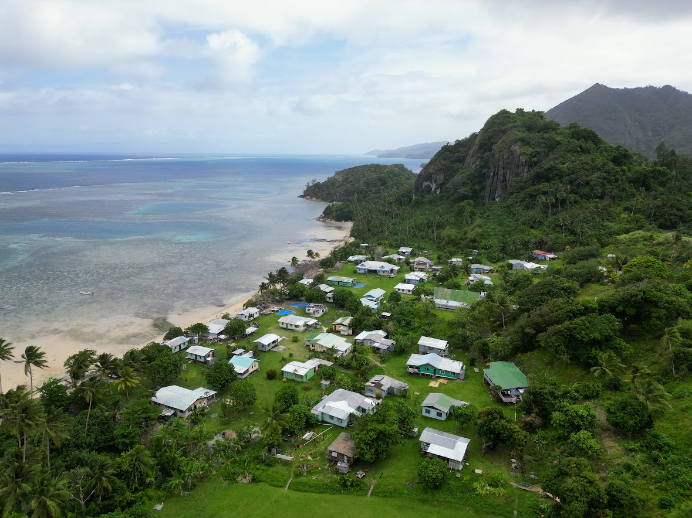

**Figure –** A community in Fiji served by the Fiji Rural Electrification Fund

* Completed a joint Infratec-PCREEE training workshop on Business Skills & Productive Use of Energy Training for Community Members in the islands of Kotu and ‘O’ua, Ha’apai.
* Continued coordinating the ISA-STAR C effort on developing a quality solar infrastructure framework for the PICT.

**Energy Efficiency Investment**

* Completed a National Workshop at Noro Province in the Solomon Is on operationalizing their MEPSL legislation at their international port.
* Completed a coherent review of the Republic of Marshall Islands National Energy Policy, in collaboration with SPC-Nationally Determined Contributions (NDC) in Majuro, Marshall Islands.

**2. Detailed overview on outcome and output level based on the results framework in the project document (later business plan)**

PCREEE Results Framework

|  |  |  |  |  |  |
| --- | --- | --- | --- | --- | --- |
| **Development Impact (ultimate outcome)** | **Indicators** | **Baseline and targets** | **Means of verification** | **Risks and assumptions** | **Progress / Comments** |
| Improved access to modern, affordable, and reliable energy services, energy security, and mitigation of negative externalities of the energy system by promoting renewable energy and energy efficiency investments, markets, and industries in PICTs. | - % increase of people with access to modern, reliable, and affordable energy services provided by RE technologies baseline 2017  - % increase of the RE and contribution to the electricity and transport mix of the PICTs (baseline 2017)   - Increase of investments in RE&EE projects in PICTs baseline 2017 in USD  - declining growth of fossil fuel use in power generation and land transport compared to BaU scenario. baseline 2017  - % decrease of GHG tCO2 emissions through implemented RE&EE projects  - Number of additional jobs created directly or indirectly in the RE&EE sector in PICTs  - % increase of registered local companies in the RE&EE sector | **Baseline:**   * High energy costs and non-access hamper the socio-economic and industrial development in PICTs; rapid growth in fossil fuel use; low productivity and competitiveness of local key industries due to energy costs (e.g. food processing, manufacturing of niche products, fishery, tourism); low levels of RE&EE investments; lack of local energy service companies;   **Target(s):**  - 10% increase of people with access to modern, reliable, and affordable energy services provided by RE technologies (baseline 2017)  - 10% increase of the RE contribution to the electricity and transport mix in PICTs (baseline 2017)   - USD 100 million of additional investments in RE&EE projects (at least 25% of it are addressing key productive sectors in PICTs (baseline 2017)  - 2% decline in the growth of fossil fuel use in PICTs due to the introduction of RE&EE technologies and solutions (baseline 2017)  - 2% decrease of GHG tCO2 emissions through implemented RE&EE projects  - At least 100 additionally (directly or indirectly) created local jobs in the RE&EE sector (baseline 2017)  - 10% increase of registered local companies in the RE&EE sector (at least 25% of them are in the manufacturing sector) | - Regional statistics on investments in RE&EE projects in the region  - Regional statistics on GHG emissions  - Regional statistics and energy balances  - National and regional policy and strategy papers | - Investments in RE&EE projects continue to be and perceived as feasible and viable options  - Regional development of policies and legal frameworks for energy continues and creates a favourable environment for sustainable energies  - Stable political situation in countries |  |

|  |  |  |  |  |  |
| --- | --- | --- | --- | --- | --- |
| **Outcome 1: RE&EE Business Start-Up and Entrepreneurship Support** | | | | | |
| Objective: To provide differentiated support to entrepreneurial RE&EE businesses across the enterprise development life cycle (start-up, early-stage, growth, and maturity). | | | | | |
| Outputs | Indicators | Baseline and Targets | Means of verification | Risks and assumptions | Progress / Comments |
| Output 1.1 Project preparation Technical Assistance (TA) to support companies (A -start-up, B - early-stage, C- growth, and maturity). to progress until financial closure. | - No. of TAs targeting specific needs of Type A, B & C businesses  - No. of successful local businesses (Type -C) that are operating in non-RE&EE industries that have entered the RE&EE industry. | Baseline:  Absence of TAs targeting specific needs of Type A, B & C businesses.  Target(s):  At least 1 Type A, B & C businesses are supported by PCREEE annually.  Baseline:  Existing businesses consider energy as high risk and unprofitable.  Target: At least 2 existing businesses per year extend their portfolio to include sustainable energy. | - TA reports  - Training documents  - Business Registration | - The technical support facility is framed within the PCREEE Sustainable Energy Entrepreneurship Facility (PSEEF).  - All the TA and advisory work are implemented by PCREEE in partnership with selected organizations.  - There is private sector interest in investing in RE&EE projects in the region | Support to the private sector in Vanuatu through the “Promoting Renewable Energy Business Start-Ups and Entrepreneurship in Vanuatu’s Rural Areas” with the Navara Savings & Credit Cooperative Society of Vanuatu. At the end of the project, there were 36 productive uses of RE installations, 61 RE and 45 productive uses systems were distributed, an additional 47.3 kW of solar PV installations and 25 additional local businesses were powered with RE. PCREEE invested 40,000 Euro in the project and it raised additional investments of about 160,000 Euro in the energy sector of Vanuatu.  Completed a solar freezer project for the Tookina Tribal Land Conservation Association (TTLCA) |
| Output 1.2 Financial support in the PICTs to increase RE&EE business opportunities for local companies and industry. | Value of loans and co-financing grants provided to local SMEs and NGOs | Baseline: Inability of local businesses to comply with the credit criteria of financing institutions, PSEEF, etc.  Target(s): At least 10 million USD of new loans and co-financing grants to local SMEs and NGOs in 2004 | - Loan documents  - Annual reports of financing and grant institutions | - The PCREEE Sustainable Energy Entrepreneurship Facility, PSEEF is well resourced and widely known in the region.  - There is private sector interest in investing in RE&EE projects in the region  - Regional development of policies and legal frameworks for energy continues and creates a favourable environment for sustainable energies.  - Investments in RE&EE projects continue to be and perceived as feasible and viable options. | Signed a MoU with CAMCO to develop a USD 100 million public-private blend of funding for the private sector (Transforming Islands Development through Electrification and Sustainability or TIDES).  NZ and the UK are showing interests in supporting the TIDES. |
| Outputs | Indicators | Baseline and Targets | Means of verification | Risks and assumptions |  |
| Output 1.3 access to finance via different instruments, including connecting with existing financing facilities (i.e. local development banks, targeted local stimulus packages, local environment/energy funds, or ADB). | - No. of investment forums conducted and Commercial financial institutions engaged in the financing of RE&EE companies. | Baseline: the absence of a regular forum to match investors, project developers, and financiers.  Target(s): At least 1 investment forum is conducted annually. | - Investment Forum reports. | - The Financial Institutions are interested in extending providing term loans to private sector service providers for RE&EE services.  - There is private sector interest in investing in RE&EE projects in the region | Incorporated business start ups and investments in training workshops in Kiribati and Tuvalu  Completed business skills and productive uses of energy training in 2 outer islands of Tonga. |
| Output 1.4 Support to improvement of the policy and regulatory frameworks and business-enabling environment both at the regional and national levels. | - No. of inputs from the national industry associations and related businesses to the review and drafting of the sustainable energy policy and regulatory frameworks.  - No. of Promotions of income-generating activities and productive uses of energy. | Baseline:  Lack of and inactive participation of the national industry associations in shaping the sustainable energy business environment in PICs.  Target(s):  At least 3 TAs conducted to support inputs from national industry associations to the policy and regulatory framework regarding the national sustainable energy business environment. | - Training reports  - Minutes of investment forums | - Involved organisations accept and assist the support to the improvement of the policy and regulatory frameworks and business-enabling environment both at the regional and national levels.  - There is private sector interest in investing in RE&EE projects in the region | Established the Kiribati Sustainable Energy Association – KSEA.  Drafted a Legal TA and a Test and Tag training for the association in Tonga (NECAT).  Unable to conduct the training as NECAT members were unable to purchase the required meters. |
| **Outcome 2: RE&EE for Sustainable Mobility** | | | | | Progress / Comments |
| Objective: A comprehensive e-mobility readiness programme that best prepares PICTs for their respective sustainable mobility futures. | | | | |  |
| Output | Indicators | Baseline and Targets | Means of verification | Risks and assumptions |  |
| Output 2.1 Adopted Sustainable e-mobility Policy and Regulatory Frameworks | - No. of High-level energy and GHG targets and mandates that include RE and EE in the promotion of low carbon mobility  - No. of PICs with adopted regulatory frameworks and policies that consider exploring the feasibility of EVs for low carbon mobility    - A Project Document with a monitoring and evaluation system for promoting the understanding and familiarity with EVs | Baseline: Absence of EE and GHG targets on low carbon mobility, including EVs  Target: 5 PICTs include low carbon mobility / EV targets in their Energy / GHG targets by 2025  Baseline:  EE in transport, including EVs are missing from the energy roadmaps, NDCs, and Low Emissions Development Strategies  Target:  5 PICs include EE in transport and EV in their energy roadmaps, NDCs, and Low Emissions Development Strategies by 2025  Baseline:  Absence of a regional Project Document with an M&E system for promoting the understanding and familiarity with EVs  Target  A regional EV Project Document is adopted by the PCREEE Steering Committee in 2021 | - National Energy and GHG roadmaps and policies  - NDCs  - LEDS  - Regional EV Project Document | - PICs continue to push for urgent and ambitious energy / GHG targets | E-mobility features more prominently in the second / enhanced NDCs of PICs as well as in the regional energy framework (FESRIP) that was adopted by Forum Leaders.  Completed support to the NREL-drafted policy for the promotion of EE in the Transport Sector of Tonga  Delivered a TA to the Cook Is power utility on strategically positioning EV chargers and other EV considerations in Rarotonga. |
| Output 2.2 Adopted Standards and Guidelines | - No. of model Standards and Guidelines developed for aspects of EVs retirement of EVs, low-voltage vehicles, mobility batteries, standards for “EV-ready” new constructions  - No. of other model Guidelines and Standards set for other aspects of EVs including charging connectors, use of V2H and on-site management charging, e-mobility security, and available options  - No. of Technical courses developed and introduced on EVs | Baseline: Absence of any model standards and guidelines on EVs    Target: At least 5 PICs have adopted EV standards and guidelines relating to the retirement of EVs, low-voltage vehicles, mobility batteries, standards for “EV-ready” new constructions by 2025 Programmes  Baseline: Absence of any model standards and guidelines on EVs    Target: At least 5 PICs have adopted EV standards and guidelines relating to charging connectors, use of V2H and on-site management charging, e-mobility security, and available options  by 2025  Baseline: Absence of EVs from technical courses related to mechanical/electrical engineering  Target: At least 3 technical institutes in the PICTs deliver technical courses that cover EVs | - National energy standards and guidelines | -There is political will to adopt standards, guidelines, and training on EVs. | Assisted PRIF to complete drafting an EV standard. Regional validation workshop is planned for 2024  Agreed to conduct regional workshop on the standards in the second half of 2024.  An e-mobility module was developed under the GEN-SEC online capacity building platform. Conducted initial workshop as part of the process of developing a regional EV qualification. |
| Output 2.3 Effective Awareness Raising and Promotion | - No. of Social marketing research is undertaken  - No. of EV awareness, information, and promotion campaign developed and delivered  - No. of Guidelines on EV purchase, charging, servicing, and support developed, published, and promoted | Baseline: No social marketing research on EVs  Target: A social and marketing research on EV is completed in at least 3 PICTs by 2025  Baseline: No targeted awareness and promotion campaign on EVs in the region  Target: At least 5 awareness and promotion campaigns on EVs completed by 2025    Baseline: No. Guidelines on EV purchase, charging, servicing, and support developed, published, and promoted  Target: There is a model guideline on EV purchase, charging, servicing, and support developed, published, and promoted by 2022 | - Social marketing research document  - Report of Campaign and awareness  - Model Guidelines on EV purchase, charging, servicing, and support | - PICTs buy into the concept that sustainable mobility offers an alternative to reduce fossil fuel dependency, increase energy security, mitigate climate change effects, and underpin PICTs domestic economies without further harming the environment. | Prepared EV awareness materials to support EV awareness events in PICTs.  Established the EV Working Group and convened their meeting. |
| Output 2.4 Successful Demonstration and Upscale | - Quality products and services system supported and developed, published and promoted  - No. of Demonstrations of technologies and business services (i.e. small marine vessels, electric bus, e-mobility charging facilities, and batter swapping, among others)  - No. of Public charging infrastructure installed and/or co-investment promoted | Baseline: Very little EV-related demo of quality EV products and services  Target: At least 2 demo EV projects by 2025  Baseline: No Demonstrations of technologies and business services (i.e. small marine vessels, electric bus, e-mobility charging facilities, among others)  Target: There is a demo of EV technologies and services, including Battery swapping for low-voltage mobility use is available on a commercial scale in the marketplace  Baseline: Hardly a public charging infrastrucrue for EVs in the PICs  Target: 50% of all mainstream EVs are charged through devices that are managed-charging enabled by 2030 | - Demonstration projects´ reports  - Managed charging stations reports | - PICTs buy into the concept that sustainable mobility offers an alternative to reduce fossil fuel dependency, increase energy security, mitigate climate change effects and underpin PICTs  - There is private sector interest in investing in RE&EE projects in the region | Supported EV demo projects in Fiji, Nauru, Tonga and Tuvalu by funding a participant each to the NZ Emobility Summit and sites visits.    Prepared for the regional workshop on EV standards which incorporated attending the 2024 NZ Electro mobility summit. |
| **Outcome 3: RE mini-grids** | | | | | Progress / Comments |
| Objective: Increased clean energy access and improved livelihoods for communities through technically sound mini-grid systems | | | | |  |
| Output | Indicators | Baseline and Targets | Means of verification | Risks and assumptions |  |
| Output 3.1 Market Intelligence: Enhanced awareness of mini-grid market and strengthen market knowledge through market intelligence development. | A Web-based market knowledge platform is established  Up-to-date market information are published and shared on the platform  A Database of Mini-grid projects in PICTs | Baseline: Limited market knowledge and data about RE mini-grids  Target: A regional Web-based knowledge platform for mini-grids is fully functional and hosted by the PCREEE by end of 2022,  Baseline: No sharing of market information and data on RE mini-grids  Target: Updated market information about mini-grids are shared on a regular/monthly basis from the platform, commencing in 2023  Baseline: No database and Little data available on RE mini-grids  Target: A fully functional database with key data is available on the platform by end of 2022 | Web-based platform available  No. of hits/visits to the platform  Data collection sheets    Database available | The willingness of the PICT and project developers to share data and information.  Risk that lack of ICT connection may hinder access to the knowledge database | Data collection and market research are on-going. |
| Output 3.2 Capacity Building, Public and Private Partnerships: Empowered local institutions and private sector and increased project developments through capacity building and reinforced networks and partnerships between stakeholders. | A Pro-Poor Public-Private Partnership (5P) business model is developed for mini-grids  A Capacity building program on mini-grids is delivered  No. of Promotion of mini-grid and public-private partnerships conducted  No. of national sustainable energy industry associations established to support mini-grids | Baseline: - Unclear pro-poor business model for mini-grids  Target: A 5P business model is developed to assist in sustainably managing mini-grid systems in the PICT.  Baseline: Ad-hoc delivery of capacity building services in mini-grids  Target: A regional capacity building programme on mini-grids is adopted by end of 2021  Baseline: No promotion of mini-grid and PPP conducted  Target: At least 3 PPPs on mini-grid signed by end of 2024  Baseline: 3 national industry associations have been established  Target: An additional 5 national industry associations are established by end of 2024 (i) | PCREEE Progress Reports Minutes of the PCREEE Steering Committee meetings  Annual Report of the PIC national energy offices  Reports of capacity building events  PPP signed [if not confidential] | Energy access remains a high priority in the PICT  Governments  Governments are pro-poor and support private sector-led developments | Completed regional mini-grid workshops with TTA and UNIDO.    Conducted joint regional mini-grids workshop on accelerating the transition and resilience with GGGI, ASU, USA and USP.  Conducted off-grid workshop with the same partners and including UNDP and the Fiji Rural Electrification Fund.    Established the Kiribati Sustainable Energy Association. |
| Output 3.3  Increased entrepreneurship through productive uses of energy. | No. of micro and SMEs established due to the improved reliable supply of energy  Increased jobs and income-generating activities due to the improved reliable supply of energy | Baseline: Unknown number of new micro and SMEs established  Target: At least 5 new micro and SMEs established by end of 2023  Baseline: Unknown number of new jobs and income-generating activities  Target: At least 50 additional jobs and USD 100k of additional income due to new micro and SMEs | Business Registration and Licenses  Tax records  Business tax returns and salary slips | Other supporting incentives from govt empower people with the confidence to start new micro and SME. | Conducted productive uses of energy workshop at ‘Eua Island.  Conducted workshops on business skills and PURE in two islands of the Ha’apai Group in Tonga. |
| **Outcome 4: Energy Efficiency Investment** | | | | |  |
| Objective: To enhance the competitiveness of manufacturing and service industries in the Pacific Region while reducing Greenhouse Gas (GHG) emissions by mobilising additional investment for public institutions and private sector organisations in the market of domestic, industrial, and commercial EE. | | | | |  |
| Output | Indicators | Baseline and Targets | Means of verification | Risks and assumptions |  |
| Output 4.1 International standards (ASHRAE, ISO, ANZ, etc) adopted for lighting and thermal efficiency and potentially included in building codes. | - No. of Validation workshops and TA support for PICTs on appliance labelling and standards | Baseline: 5 PICs have adopted legislation on labelling and standards for refrigerators and freezers and are enforcing their legislations  Target: An additional 5 PICs adopt legislations on labelling and standards by 2025. | - Cabinet Decisions  Parliamentary records | There is a commitment from governments to remove inferior products from the market. | Supported Kiribati to operationalize its MEPSL.  Conducted refresher training on MEPSL in Tuvalu.  Conducted training on operationalizing the MEPSL at the Noro Province of the Solomon Islands. |
| Output | Indicators | Baseline and Targets | Means of verification | Risks and assumptions |  |
| Output 4.2  Assistance provided to PICTs for adopting energy conservation practices for the design, construction, and utilization of energy-efficient facilities. | - Conservation practices guidelines, mandatory consumption reporting, energy saving plans, maintenance plans, TA, and forums to support PICTs and encourage the private sector to step in. | Baseline: EE practices are not integrated into the design of infrastructure and public facilities    Target: At least 5 PICs incorporate EE considerations in their building, transport, and work safety codes by 2024. | Building codes  Transport costs  Work Safety codes | Involved organisations accept and implement the practices. | EE effort and activities were mostly focused on EE in land transport. |
| Output 4:3. Access to financing via different instruments facilitated. | - No. of EE financing instruments, research study, consultation workshops with relevant institutions, TA support to public and private organisations, and seed-funding grant provision. | Baseline:  Limited financing available for EE investments  Target: at least USD 10 million is available for EE investment in the PICT by end of 2024 | - Donor reports  - Financing Institutions reports | Availability of a credit risk facility to safeguard investors. | EE funding are included in the investment forums and funding discussions with CAMCO, etc  NZ and the UK are interested in supporting the TIDES. |

**4. Main problems and constraints encountered and counter measures taken:**

* **The PCREEE is understaffed and under-funded.**

The PCREEE has only two SPC-paid staff at the moment, the Manager and the PA. Though the MoA with Tonga calls for two civil servants to work for the PCREEE, the Ministry can only afford to give PCREEE one at the moment. There is a STAR-C Coordinator funded by UNIDO which is now vacant and there is a need to more effectively integrate the work of this Coordinator with the related work of the PCREEE.

**5. Proposed way forward:**

It is a matter of balancing the budget for personnel with the provisions for on-the-ground activities.

It is encouraging to note that through closer collaborations within the Energy Programme, the MFAT Climate Change Flagship programme will support the PCREEE’s sustainable mobility effort while the UK’s will support the PCREEE’s capacity building and the and empowering local officials to be able to convene and deliver more in-country activities that are aligned with national priorities.

**6. Attachments:**

* Signed Financial Report.

**Report prepared by:**

Manager - PCREEE:



__________________________________

Tonga, 2nd October 2024